**ACKNOWLEDGEMENT**

The solo motto of knowledge is always striving for perfection and betterment. And when that ambitious knowledge is given a chance to conquer the odds of the world, Science respires.

Humans are the only guardians universe got and their existence is extremely mandatory, but with change in chronology, humans may not survive the conditions that are about to occur, in the meantime somebody must Avenge the vanquish of Resources, but earth will no longer be a good home, so we here by taking the initiative to built a settlement called Ātman in space. This space station stands independent and produces its own energy Using science & technologies as vital tools forever.

The Glorious version of this world is, a talent always gets its opportunity and one that opportunity was given to us by RGUKT (A place where talent meets opportunities).

We are very privileged to be a part of the **NASA AMES SPACE** settlement contest. It helped us to cross the boundaries of isolation and exposed us to the new world of space and its wonders.

**ABSTRACT**

The brightest minds of the world would also fail to understand what happens in the next second, so how do we believe in continuation of survival on earth, which is now a hotspot for all types of calamities and disasters?

The answer to this question is not so typical to think of, but implementation takes all of it. In this vast world, only earth inhibits specific atmospheric conditions that are suitable for human survival, and copying the same on to another planet takes a great risk.

However, we, humans are well known for our courage and great risk taking abilities, as in, we brought up this idea, **Ātman** a sophisticated independent space settlement with state-of-the-art laboratories.

**Including**:-

1. Bio-regenerative life systems

2. Carbon Dioxide Capture mechanism for generating Oxygen & utilizing Life Support Systems.

3. Weather Monitoring and Radiation Alerting Technology (WHMRAT).

4. Novel Mechanisms for Information Transfer

5. Antennas for Solar System Exploration (NMIT-ASE)

6. This project will float in the orbit of Mars extracting minerals from asteroids and observing the changes on the surface of Mars.

This will be a new home and can be a suitable settlement for those who are looking for new space stations when required.

Deepest Gratitude to

Prof. V. Venkata Raman M.B.A. Ph.D

Vice chanceller incharge for RGUKT Basar

Prof. Satish Kumar Peddapelli M.Tech Ph.D

Ass. Prof. S Chand Rakesh Roshan Ph.D

Thanks for joining us and making this an epic project

Thanks for giving this divine knowledge and wisdom of yours to us dear God, you are the almighty, pave a great path to our work.

**CHAPTER-I**

**IA) INTRODUCTION**

The appealing structure of the **ATMAN** consist of highly advanced technology and the designing configured as may upgraded in future if the technology introduced later is better than currently using.

**ATMAN** is composed of six segments:

1. Torus α

2. Torus β

3. Torus γ

4. Torus δ

5. Torus Σ

6. Central Hub

i. Central cylinder

a.Storage Units

b.Transportation

ii. Upper Thrusting Section

a.Two upper minor thruster

b.One upper major thruster

iii. Lower Thrusting section

a.Two lower minor thruster

b.One lower major thruster

iv. Upper Docking Section

v. Lower Docking Section

vi. Space Observatory Lab

vii. Reflecting Mirrors

**IB) LOCATION**

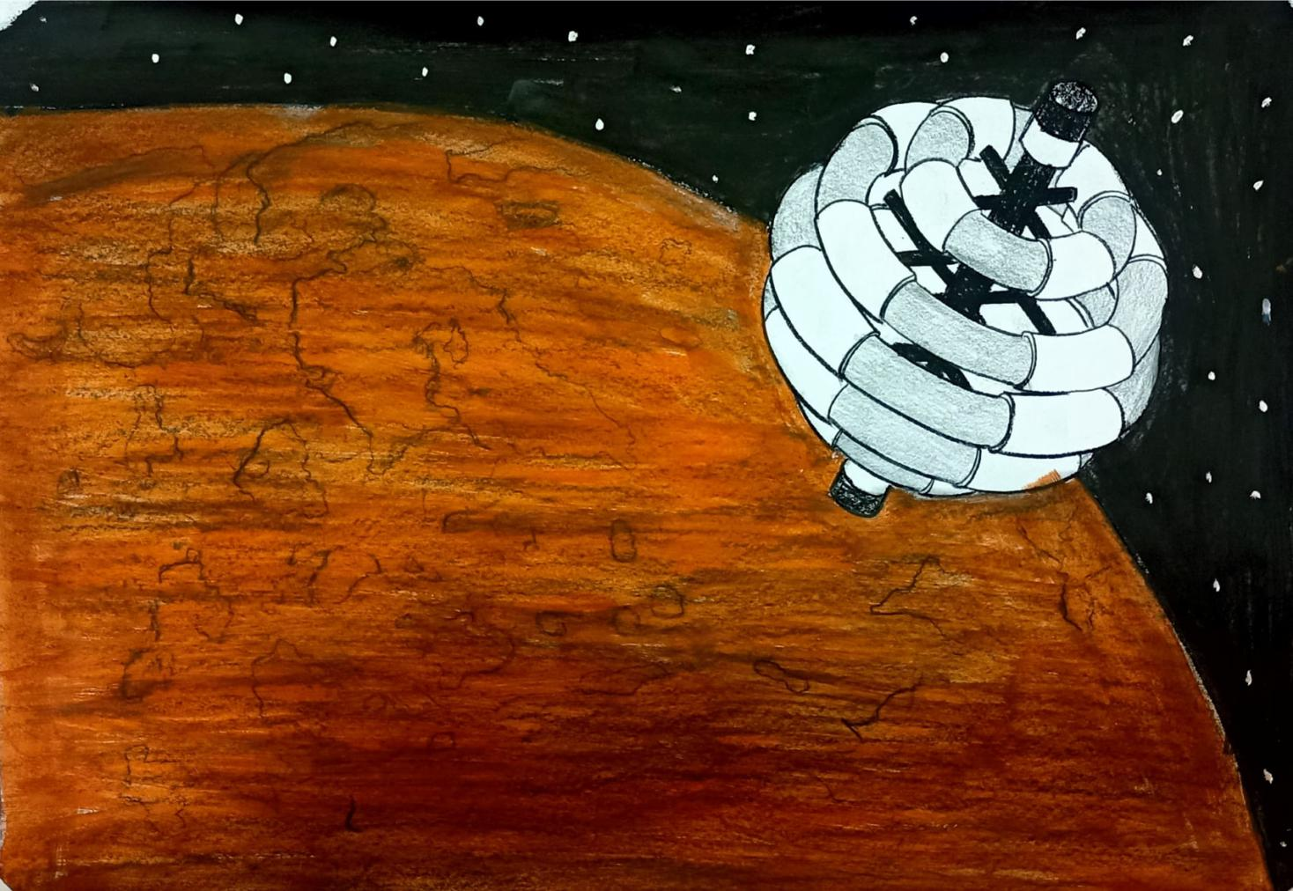

We choosen the Mars space as location of our settlement. In order to operate large amount of mining The ĀTMAN be placed in a unique polar orbit 15000 km above the Martian surface. We choosen the Mars and the location for ,we will use resources from mars and earth for the construction of ĀTMAN. ĀTMAN is independent ,it doesn't depend on earth for resources of our settlement .It extracts the resources from the Mars and it's moons.

We choosen mars to explore the Mars and behind the mars keenly. Now we are trying to settlement on Mars our settlement provide more information about settlement on Mars .So that mars will become as second earth for living.

The location is close to the asteroid belt compared to the other locations.So,it becomes easy to extract minerals from the asteroids.The location is in between the Deimos and the Martian surface mars. So we can extract resources from both mars and Deimis. Phobos also used for our the mining.This location allows the settlement to cover an exceptionally vast amount of the Martian surface.

**IC) STRUCTURE ILLUSTRATION:**

Striking features of the ATMAN SPACE SETTLEMENT gives life to mass number of Human Beings.

**I. The ATMAN be composed of five torus system of same minor radii which gives more space to us**

1. Torus - The most important torus in all other torus .It contain Industries,Mining Extraction Processing Units.

ii. Torus - This torus is consist of research labs ,Nuclear Power plant with all safety measures etc.. and the shelter will be provided to them to stay there it self .

iii.Torus - The major torus in the settlement is also a major residential torus where the life survives mostly.

iv. Torus - This is a minor residential torus.

v. Torus - This torus is also called as green torus because the green life is exist here ,this is a agricultural torus and our settlement speciality was the crop based industries are built beside the fields, which gives easy access to processing of production.

**II. THE CENTRAL HUB**

Central Cylinder is of height 2740 meters . It is composed by storage units Transportation , Thrusting sections, Docking sections, space observatory lab, reflecting mirrors, connection to torus.

**i. STORAGE UNIT :-**

a) water storage :- The extracted water from martian polar icecaps are stored here, and supplied from here to all torus .

b) food storage :- The processed final food products are stored here.

c) Industrial storage :- The industries produced products are stored here.

**ii. TRANSPORTATION :-**

All spokes contains MAGLEV (magnetic levitation) type transportation and central hub consist of MULTI DIRECTIONAL ELEVATOR type system , It carries goods ,fuel,food..... from one torus to another and to storage units.

**iii. THRUSTING SECTION :**-

The central hub consist of six thrusters. Four minor for side move and two major for up and down movement of the settlement.

**iv. DOCKING SECTION :-**

We have two docking sections upper docking section is for the ships used for mining activities and the lower docking section is for the ships used for transportation,space trips etc...

**v. SPACE OBSERVATORY LAB:-**

We have a great innovative idea –for a clear note we have to observe for a period of time,as the torus rotates we didn’t get a

proper observation on asteroids,planets,meteroids etc.. so we have decided to place the space observatory lab in the central hub as it not rotates.

**vi. REFLECTING MIRRORS :-**

The major light source sun only gives light to the half part of the torus , so we provides another half part with the help of mirrors.

**vii. CONCAVE LENS:-**

The lens which splits the sunlight to sides and gives natural light to the torus and . this process reduces the usage of electricity and gives directly natural sunlight .

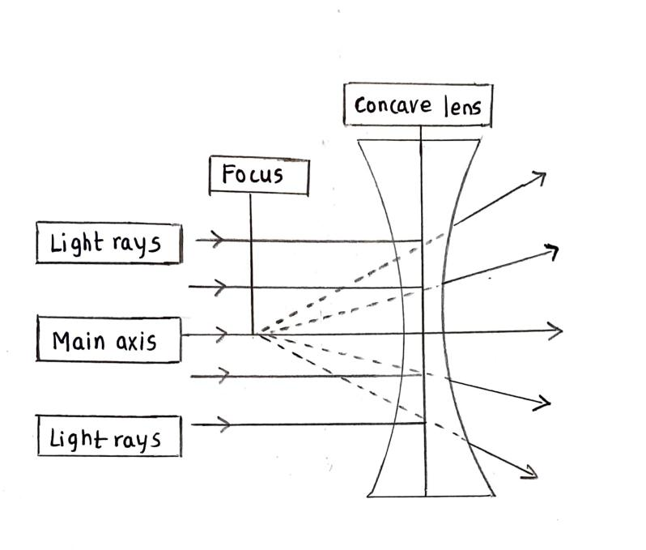

**viii. CONNECTION TO TORUS :-**

The central hub is connected to torus with spokes

**ix. OPAQUE SHEET:-**

This is used to cover the transparent part of torus to make day and night.

**ID) STRUCTURE SEQUENCE**

1. Firstly the central hub of ATMAN should build.

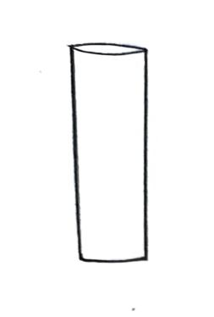

1. Next building of belt containing shaft of motors.

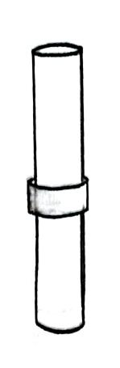

1. Completing the central hub by building total five belts containing motor shafts.

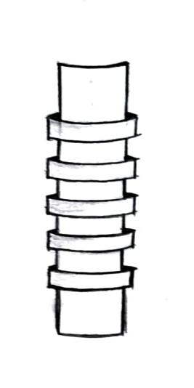

1. Building up of spokes

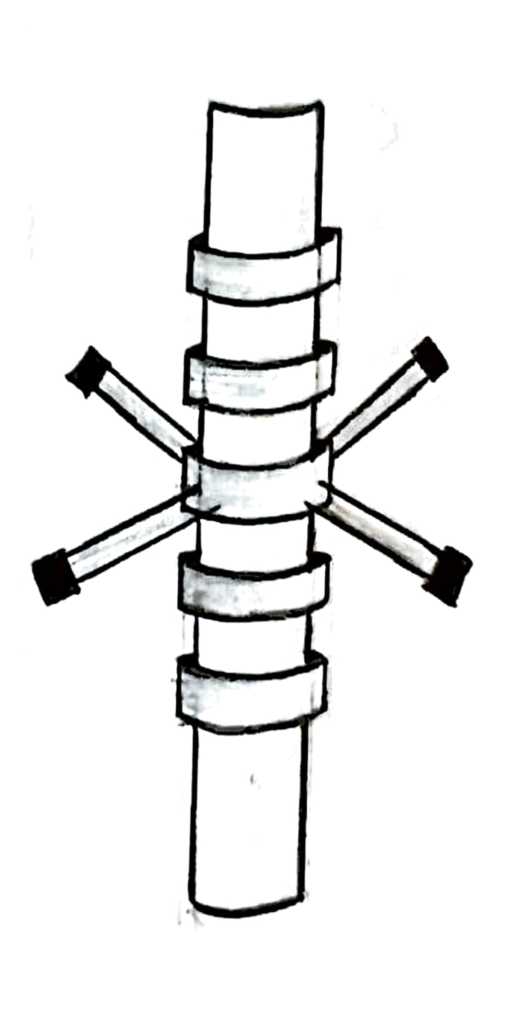

5.Next joining of spokes to other four belts

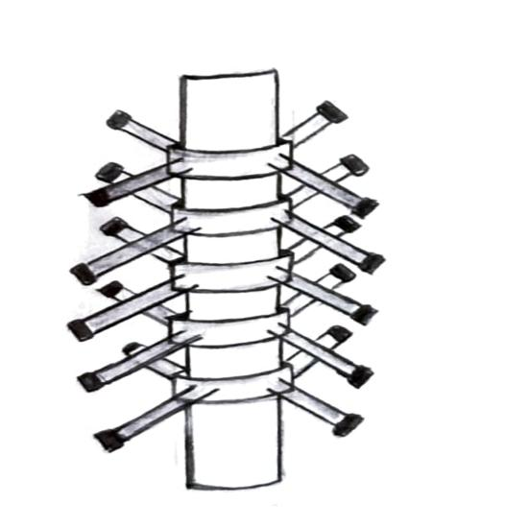

6.Welding of torus step by step to spokes

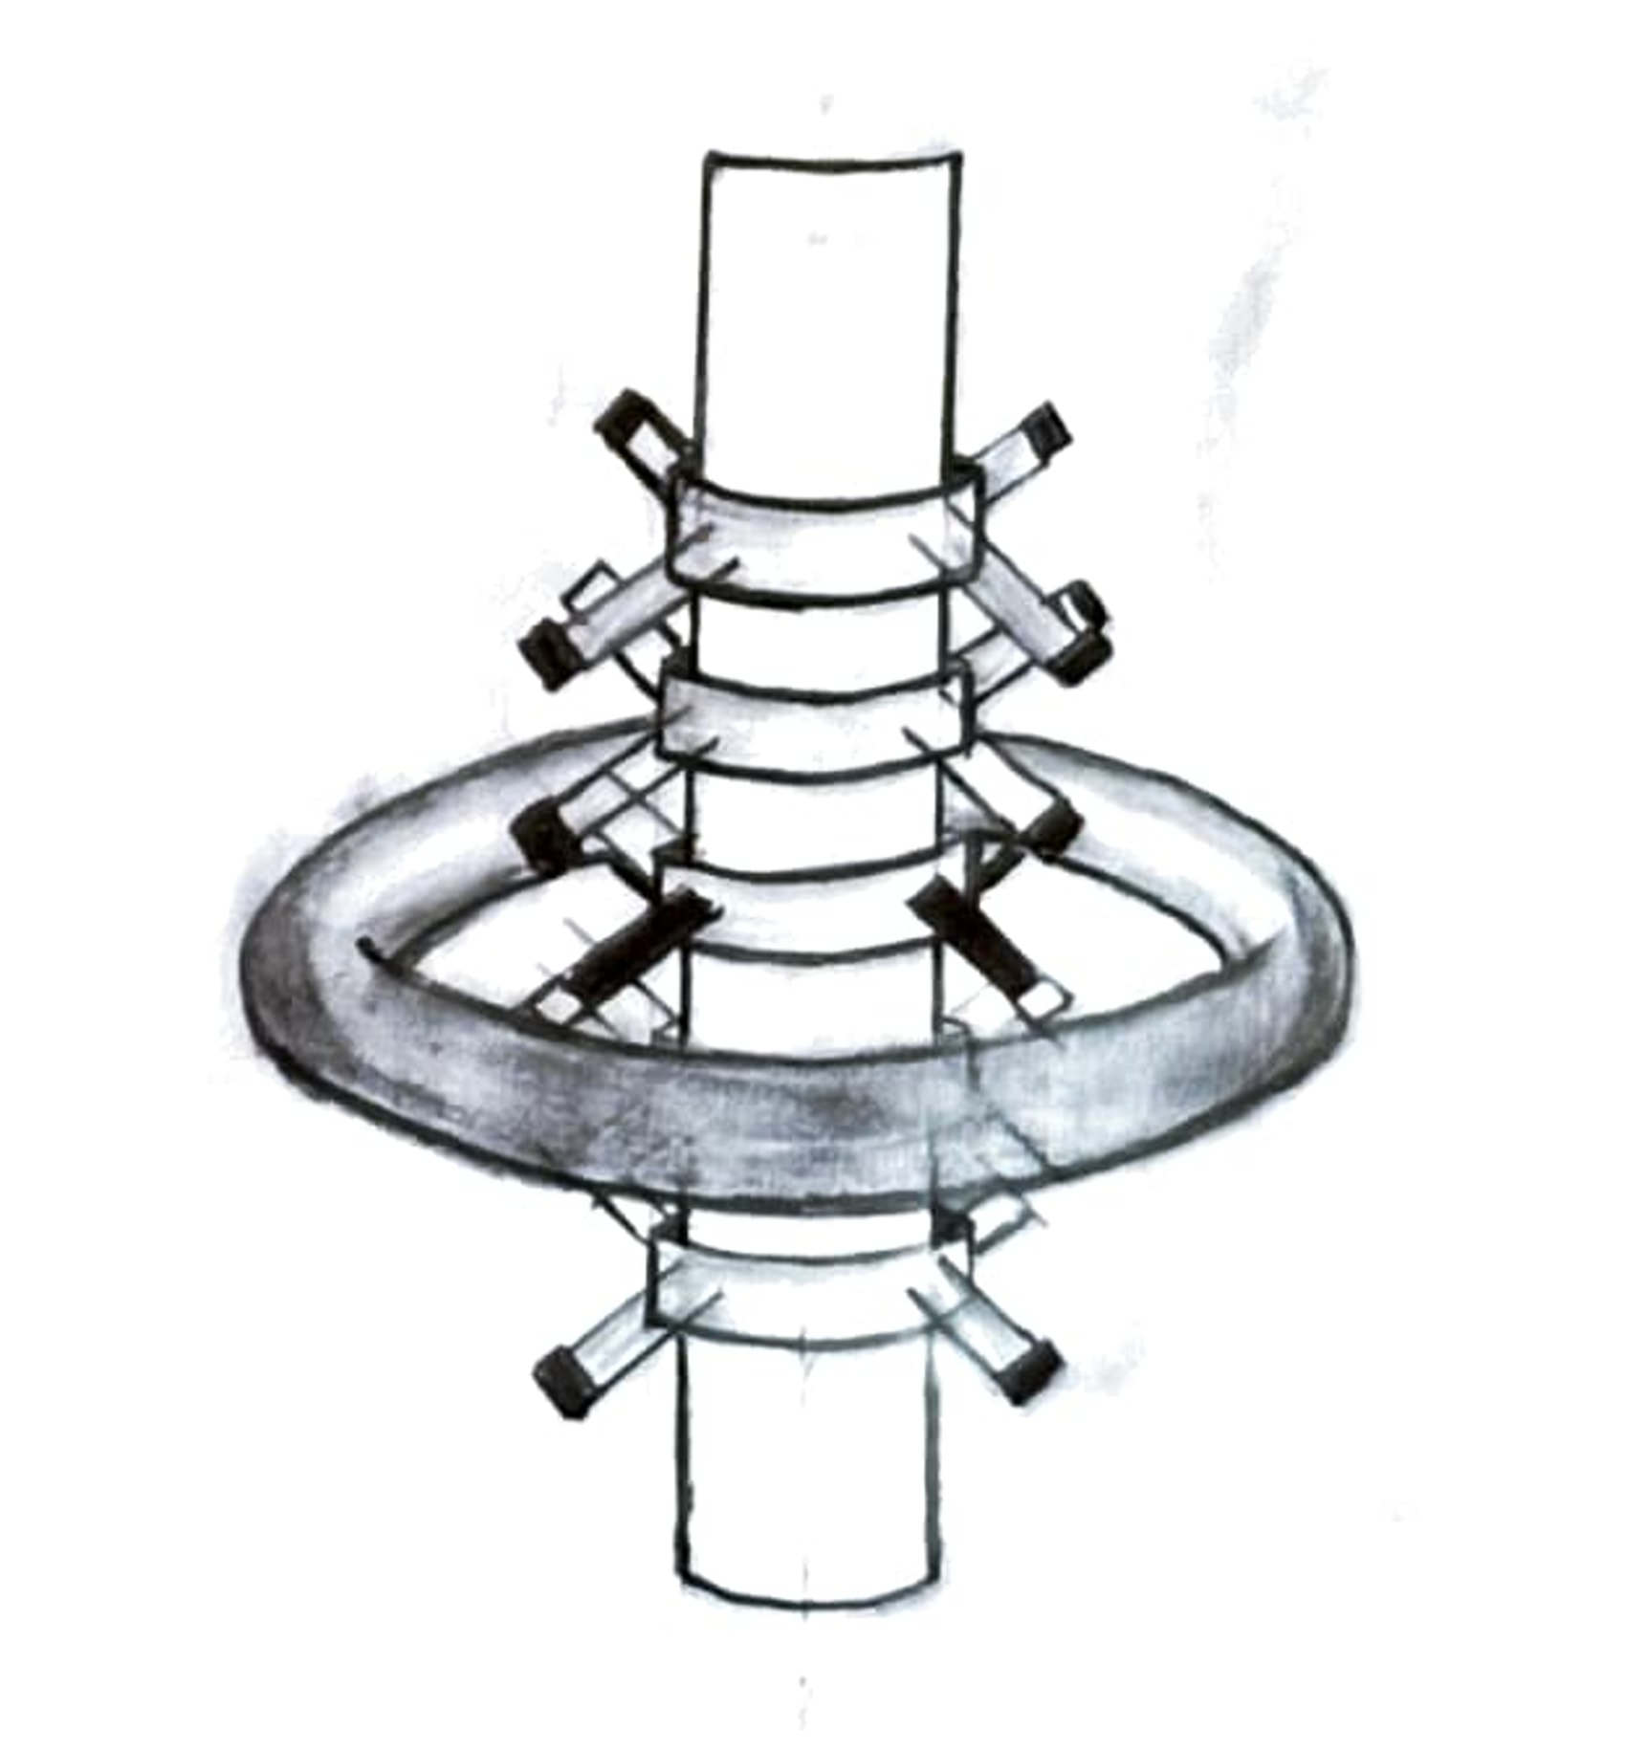

1. Welding of torus to all remaining torus

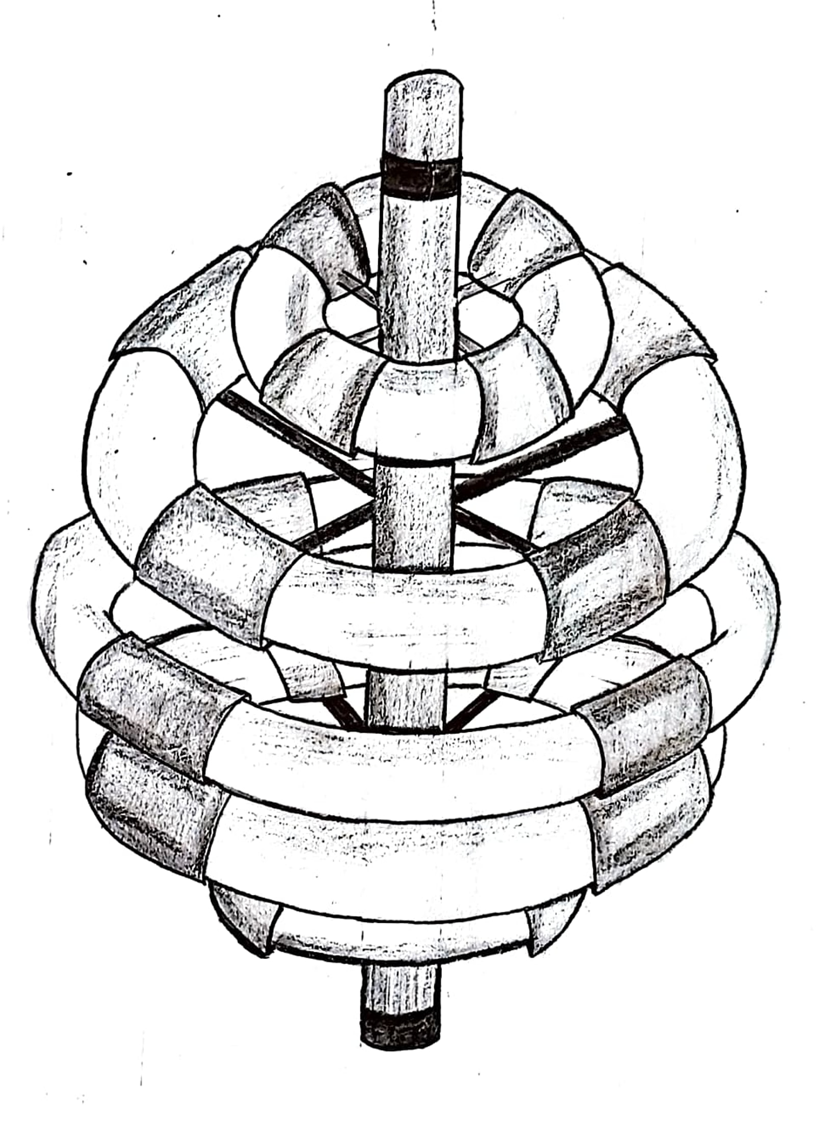

**IE) AREA AND VOLUME OF THE SETTLEMENT**

|  |  |  |  |  |  |  |
| --- | --- | --- | --- | --- | --- | --- |
| STRUCTURE COMPONENT | DIMENSIONS | | | SURFACE AREA(m) | USED SURFACE AREA | VOLUME |
| MAJOR RADII | MINOR RADII | HEIGHT |
| TORUS | 595M | 156M |  | 3660672.2 | 1464268.8 | 285532438.4 |
| TORUS | 990M | 156M |  | 6090866.4 | 2436346.5 | 475087586.688 |
| TORUS | 1120M | 156M |  | 6890677.2 | 2756270.8 | 537472825.3 |
| TORUS | 990M | 156M |  | 6090866.4 | 2436346.5 | 475087586.6 |
| TORUS | 595M | 156M |  | 3660672.2 | 1464268.8 | 285532438.4 |
| **CENTRALHUB** | | | | | | |
| UPPER DOCKING SECTION | 155M |  | 150M | 296887 | 296887 | 11315775 |
| LOWER DOCKING SECTION | 155M |  | 110M | 257951 | 257951 | 8298235 |
| SPACE OBSERVETARY LAB | 165M |  | 10M | 20724 | 20724 | 51810 |
| UPPER THRUSTING SECTION | 155M |  | 90M | 238483 | 238483 | 6789465 |
| LOWER THRUSTING SECTION | 155M |  | 90M | 238483 | 238483 | 6789465 |

**CENTRAL HUB SPECIFICATIONS**

1.Upper major thruster for down movement

2 Lower major thruster for up movement

3.Upper minor thruster for right side movement

4.Upper minor thruster for left side movement

5.Upper docking section for mining space ships

6.Space observatory lab for a detailed observation asteroids,meteroids,plantes.... this lab is outside of the central hub inner part of the lab is same as shown in figure.

7.Lower docking section for space crafts ,space trip ships etc..

8.Lower minor thruster for left side movement

9.Lower minor thruster for right side movement

10. & 11. big reflecting mirrors ,which gives sun light to the half part of torus where the sunlight doesn’t falls directly.

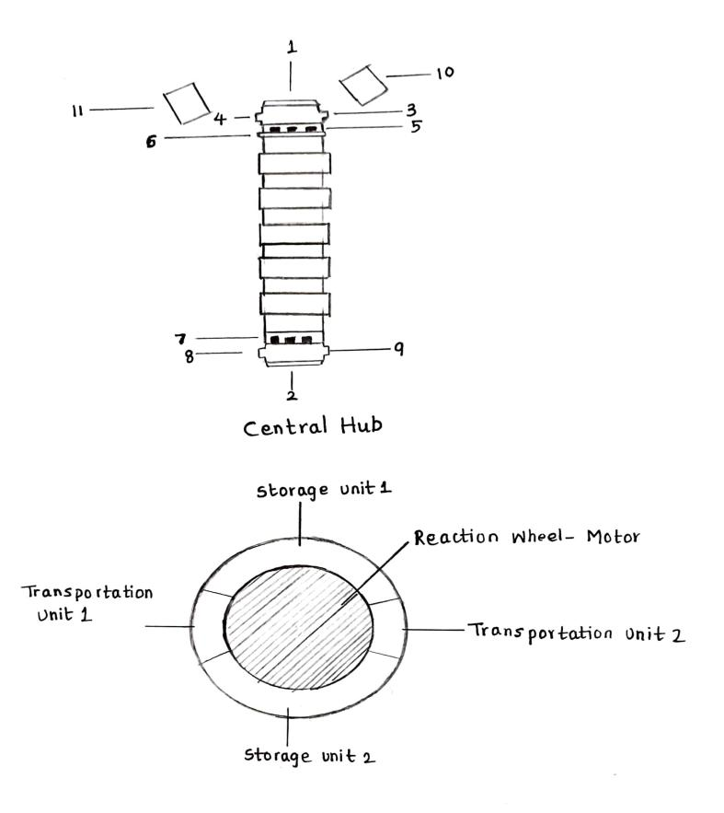

**METHOD OF ROTATION :**

**Reaction wheel technology**

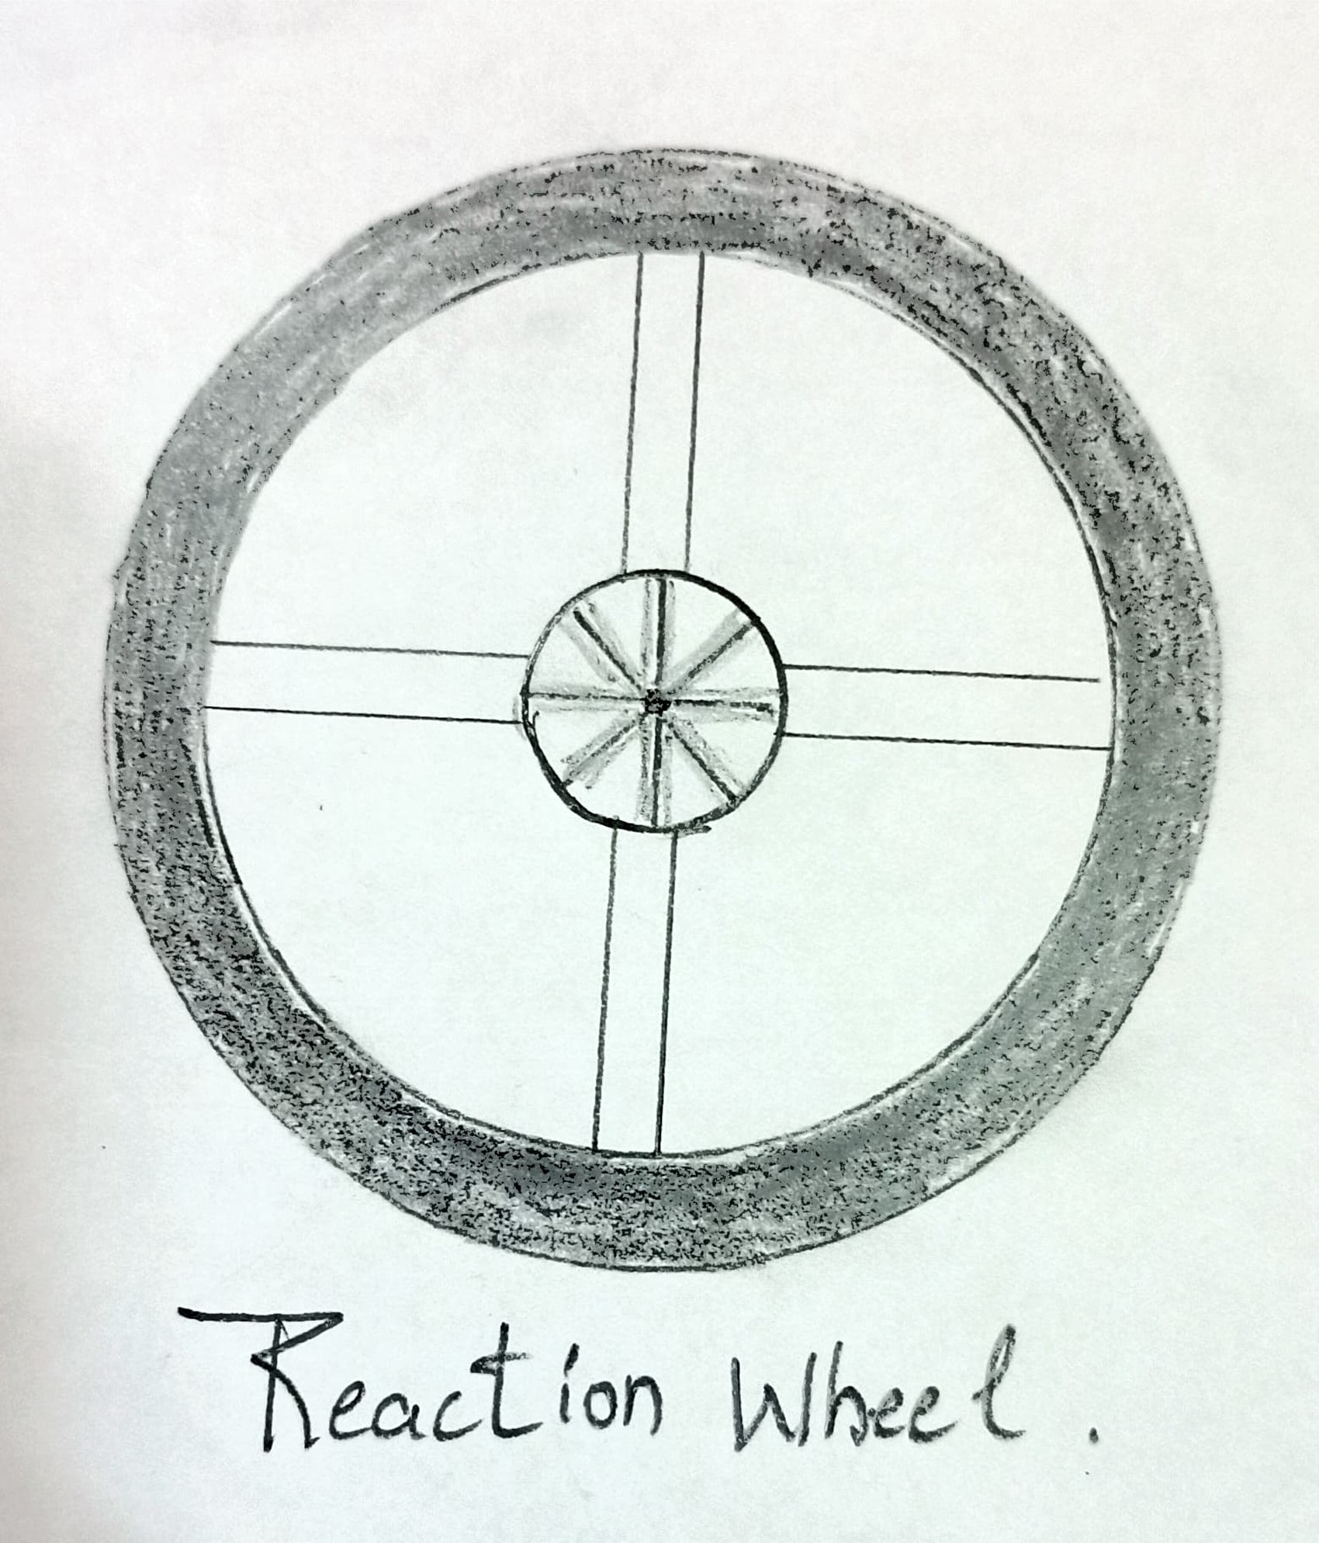

Commonly used in the satellites today. Based on Newton’s third law,the principle of this technique is very simple. In the satellites, small reaction wheels are used to manipulate the orientation of the satellite. As these reaction wheels turn in one direction,the satellite turns in the opposite direction as the reaction force. The angular position of the satellite could then be adjusted by directing the reaction wheels to turn for a specific angle, which in turn rotates the satellite proportional to its mass. Likewise, a wheel placed at the center of the torus would

Provide such motion. The wheel shown on the diagram, could be

A permanent solution for the manipulation of the spin velocity. The energy to turn the motors will be supplied from the photovoltaic cells

generating electricity from sunlight. Solar panels mounted on the wheel would supply the energy. In emergency situations or when the station needs to decrease its speed the reaction will be turned in the same direction of the rotation of the torus, so that the torus would

reaction wheel respond to it by trying to turn in the opposite direction, eventually decreasing its speed.

**IF) ARTIFICIAL GRAVITY**

Artificial Gravity is the creation of an inertial force that mimics the effects of a gravitational force, usually by rotation. Artificial gravity, or rotational gravity, is thus the appearance of a centrifugal force in a rotating frame of reference (the transmission of centripetal acceleration via normal force in the non-rotating frame of reference), as opposed to the force experienced in linear acceleration, which by the equivalence principle is indistinguishable from gravity. In a more general sense, "artificial gravity" may also refer to the effect of linear acceleration, e.g. by means of a rocket engine. In the context of a rotating space station, it is the radial force provided by the spacecraft's hull that acts as centripetal force. Thus, the "gravity" force felt by an object is the centrifugal force perceived in the rotating frame of reference as pointing "downwards" towards the hull.

1. Centrifugal force varies with distance: Unlike real gravity, the apparent centrifugal force felt by observers in the habitat pushes radially outward from the axis, and the centrifugal force is directly proportional to the distance from the axis of the habitat. With a small radius of rotation, a standing person's head would feel significantly less gravity than their feet. Likewise, passengers who move in a space station experience changes in apparent weight in different parts of the body.
2. The Coriolis effect gives an apparent force that acts on objects that are moving relative to a rotating reference frame. This apparent force acts at right angles to the motion and the rotation axis and tends to curve the motion in the opposite sense to the habitat's spin. If an

astronaut inside a rotating artificial gravity environment moves towards or away from the axis of rotation, they will feel a force pushing them in or against the direction of spin. These forces act on the semicircular canals of the inner ear and can cause dizziness Lengthening the period of rotation (lower spin rate) reduces the Coriolis force and its effects. It is generally believed that at 2 rpm or less, no adverse effects from the Coriolis forces will occur, although humans have been shown to adapt to rates as high as 23rpm.

3.Changes in the rotation axis or rate of a spin would cause a disturbance in the artificial gravity field and stimulate the semicircular canals . Thus, the rotation of a space station would need to be adequately stabilized, and any operations to deliberately change the rotation would need to be done slowly enough to be imperceptible.

* Torus ,Torus ,Torus ,Torus and Torus contains 1g for humans,creates earth like environment ,increases human efficiency ,psychologically viable....

*Central Hub [Zero G]Central hub has no gravity for easy storage in storage unit’s,Docking Systems work best in zero G.

As we know

F=ma----------(1)

F=mv²/r---------(2)

Where

M=mas of an object lying on the periphery of the torus

R=major radius of the torus

V=velocity of the object (v=2πr/t)

T=time period of radiation=61s

Therefore,equating 1&2

Mv²/r=ma

A=v²/r

A=(2πr/t)+r

A=4π²r/t²

For torus α &Σ

A=4×3.14×595÷49²

A=9.77

A~9.8=1g

For

Torus “β &δ “

A=4×3.14×3.14×990÷63²

A=9.83 m/s²=1g

For Torus “α “

A=4×5.14×3.14×1120×/67²

A=9.83m/s²=1g

**CHAPTER-2**

**RESIDENTIAL**

Sector consists of houses, restaurents, marts, shopping malls, theaters, hospitals, schools, parks, play grounds, (stadium) adventure park, relaxation, coaching centers, temples, emergency stations, animal husbandary, reparing shops, resedential design of living rooms.

**STARHOUSE**: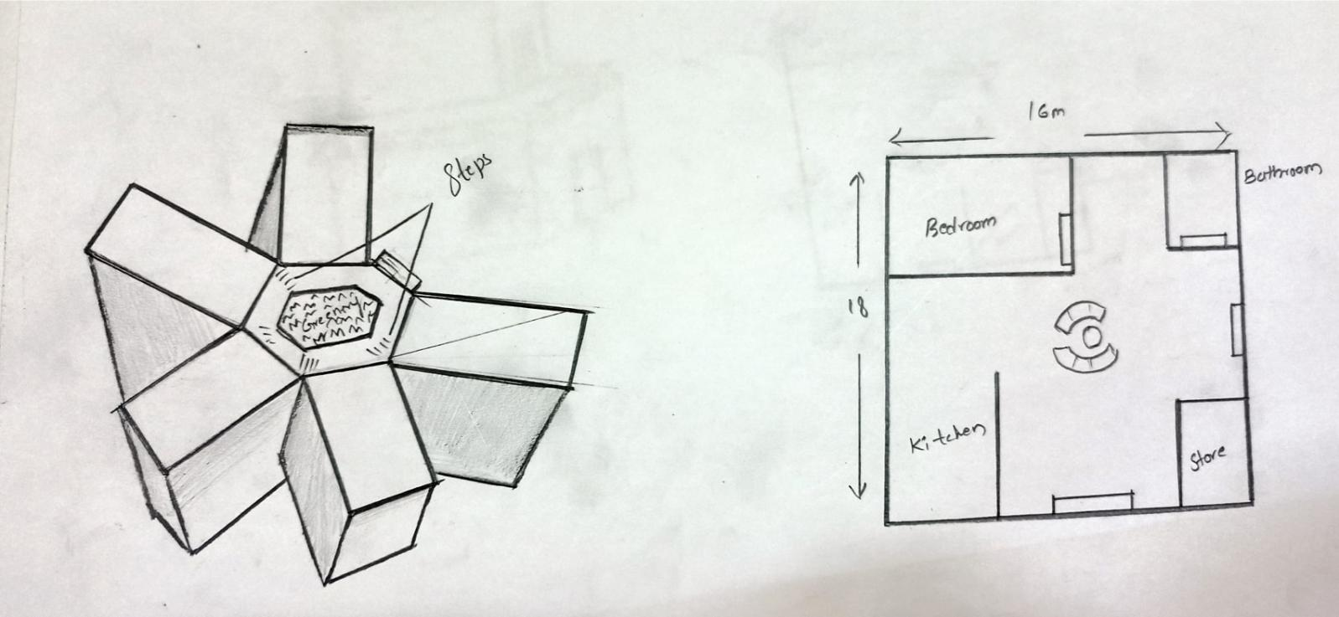

The nuclear families will stay in star house.These houses were designed by star shape multi level houses will be connected together to form star 1 star house consists 5 houses to live.

**NATURE HOUSE**:

Joint families will stay in nature house the separate independent house based on the atmospehere of village look it feels comfortable for traditional families. It also called small rural house. This houses will have a open green for relaxing.

**PAKKA HOUSE**:

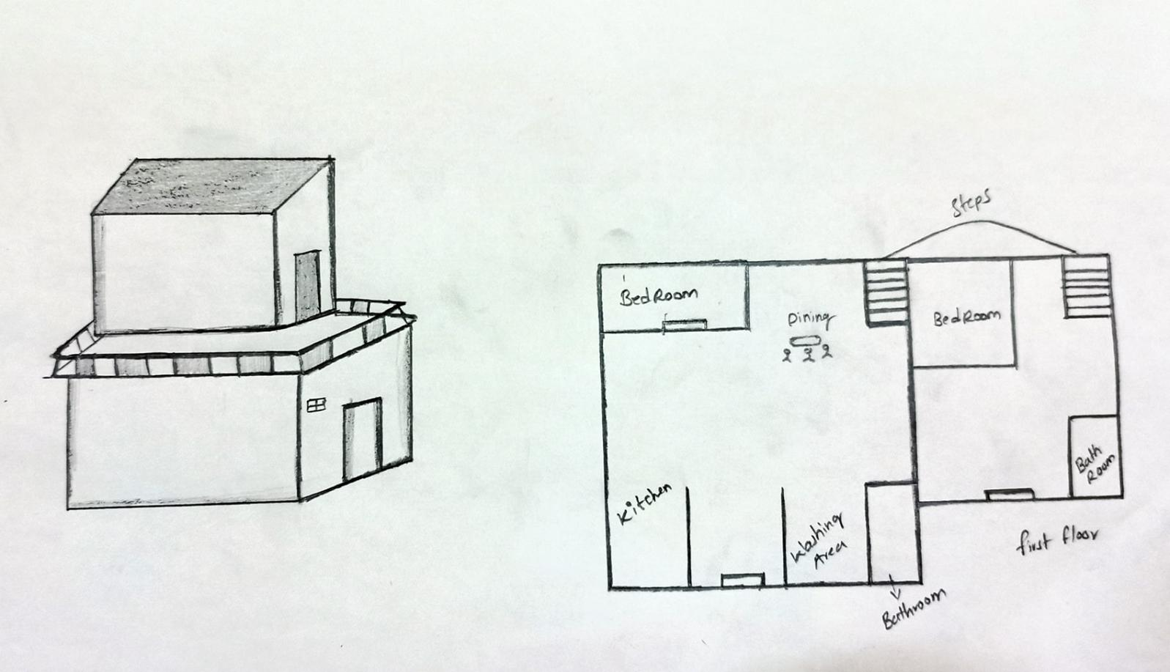Small and compact a series of multi level houses shall be connected by common side walls. These homes will be for inidividuals and couples. Based on the modern architecutral design. These would give comfortable zero.

**DUPLEX HOUSES**:

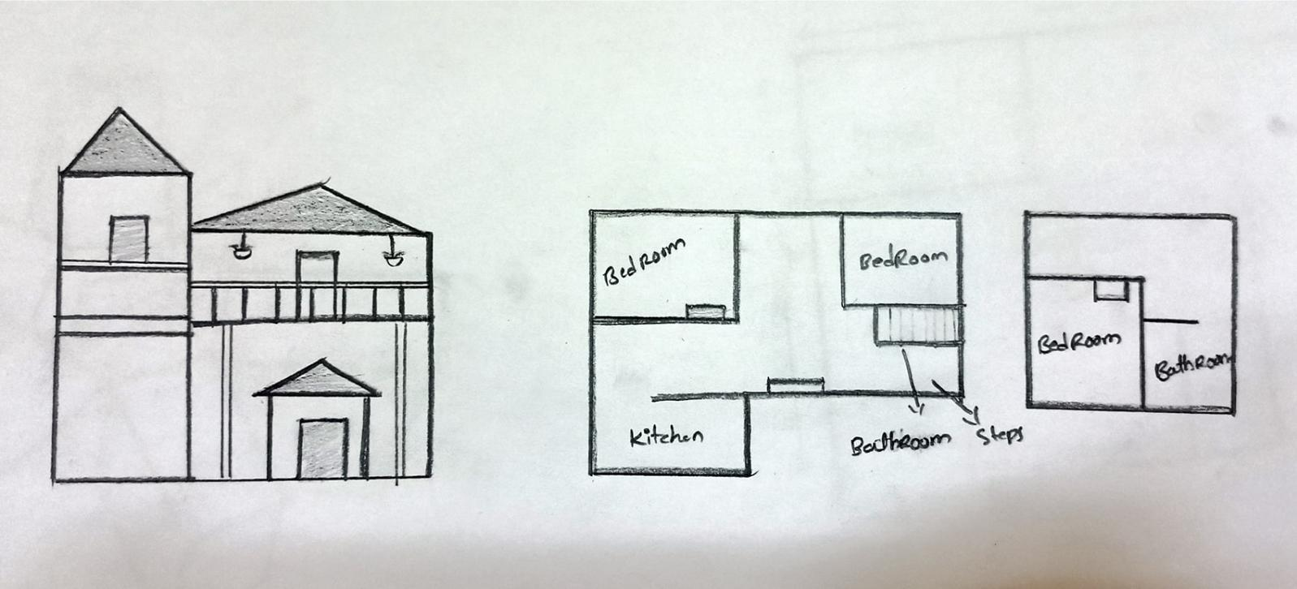

These shall be small and economical houses present near shops of daily nuds and business 1 or ½ stories houses will be for small families and couples large and open spaces for space light and ventilation shall be present with symmetrical design of the buildings.

**IGLOO APARTMENTS**

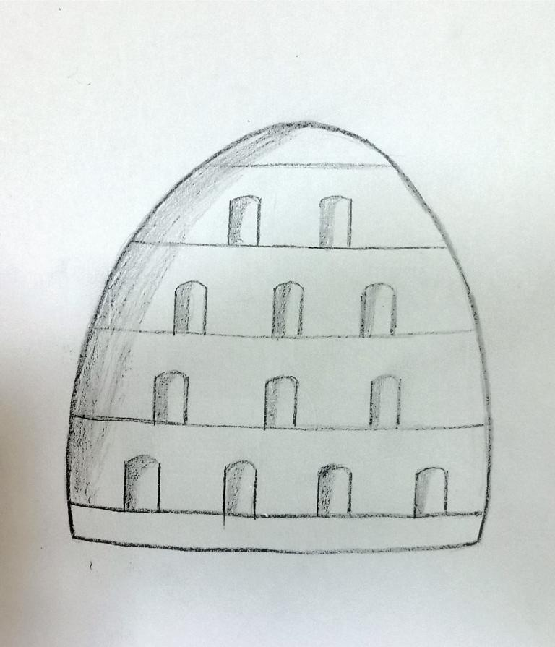

|  |  |
| --- | --- |
| TOTAL HOUSES |  |
| TOTAL AREA |  |
| PEOPLE |  |

Igloo consists 4 floors it is made up glass the modern way look of igloo will be designed igloo will be placed beside the river bank. The view of igloo will be good.

This houses consits of roof layer farming for fresh oxygen clean air. It is mandatory to farm in every independent hose roof. The cleaning robos will work as a servants in the houses.

**RESTAURENTS**:

Tourist restaurents 5 star hotel tourist restaurents it consists of swimming pool, lodges, pub, bar the tourists guest people will stay in this restaurents.

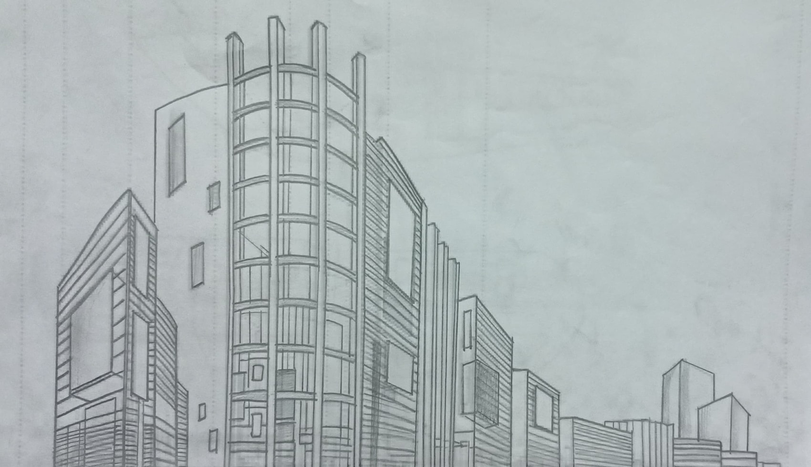

**5 STAR HOTELS**:

This hotels will survive different types of fool to the people veg & non veg.In restaurents & hotels the robots will survive to the customers man made work will be decreased by using robots in these hotels.

**MART’S / BAKERY’S:**

The grocery’s, bakery’s items will be available to buy house hold groceries, vegetables, food items will be available in the super market’s.

**SHOPPING MALLS** :Dresses and every shopping items will be available in the malls.

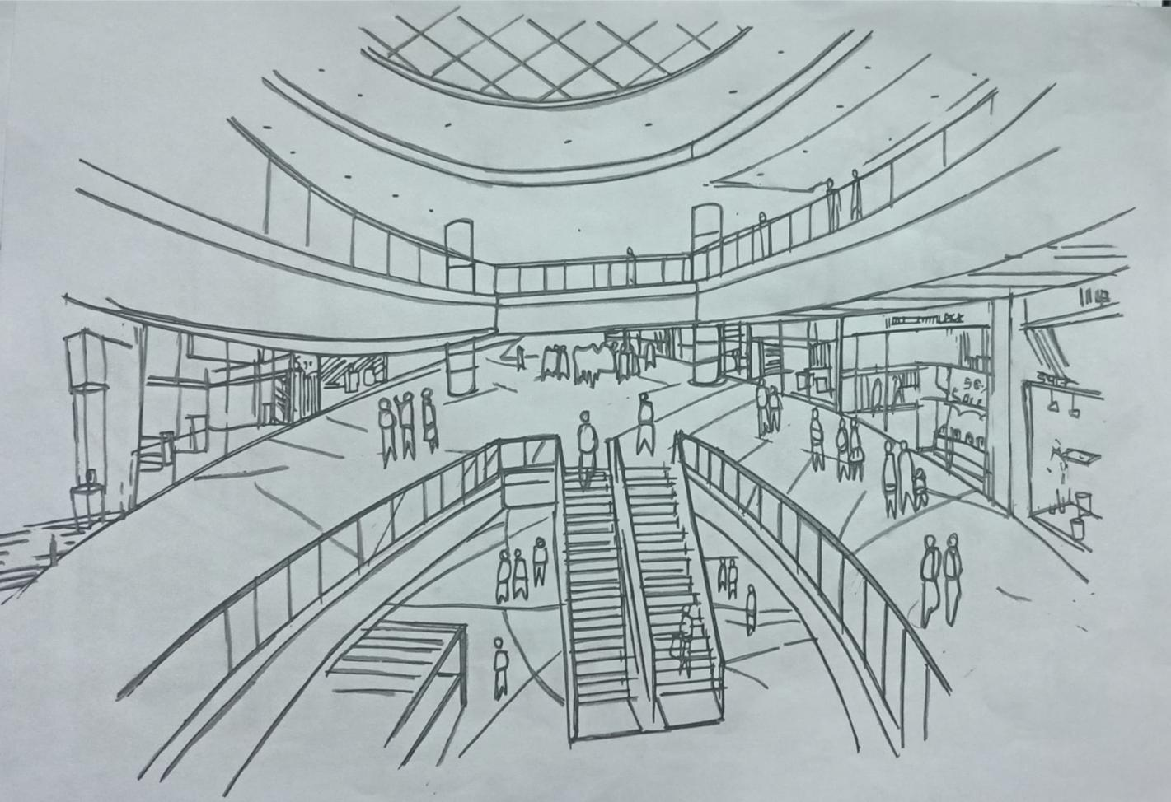

**THEATER’S:**The movies will be played in the theaters for entairnment purpose to the people. The halls will have the capacity of seating 600 people 850m s.q of area.

**HOSPITALS**: General hospital and 2 smaller helth care clinics are weated within the resedential tones where specialized departments carryout procedures from emergency care to the annual check-ups. In order to supplement the actions of highly trained doctors and surgerus a trio automated systems performs preventive measures . Intially all residents of ingest a pill containing millions of microscopic medical sensors that moniter virtal bodily functions when the micro-medical sensors detect a medical emergency the sensors detect a medical emergency the sensors notify both the medical authorities and the first responder robot (FRR) FRRS respond quickly and efficiently to medical emegencies and stabilize patients until a medical transportaition .Robot can transport them to a hospitals facility from photometric plant the medicines will be reviewd.

**PARKS**:

An array of parks and green areas are incorporated in to the design establishing an aesthetically pleasing environment the park include an abundance of vegetation and flora. All the given areas after a relaxing atmosphere for the residents and makeup 1 fifth of the settlement downarea.

**ROADS & PATHWAYS**:Resedential have acuses to a multitude of paths throughout the settlement – along the river and in and around the resedential commercial, and green areas. The paths allow residents to exercise work run or bike – while providing a low-cost alternate transportation method as well as promoting residents to engage in physical activity roads and pathways accounts for approximately 3% of the downarea.

**SCHOOLS AND COLLEGES:**

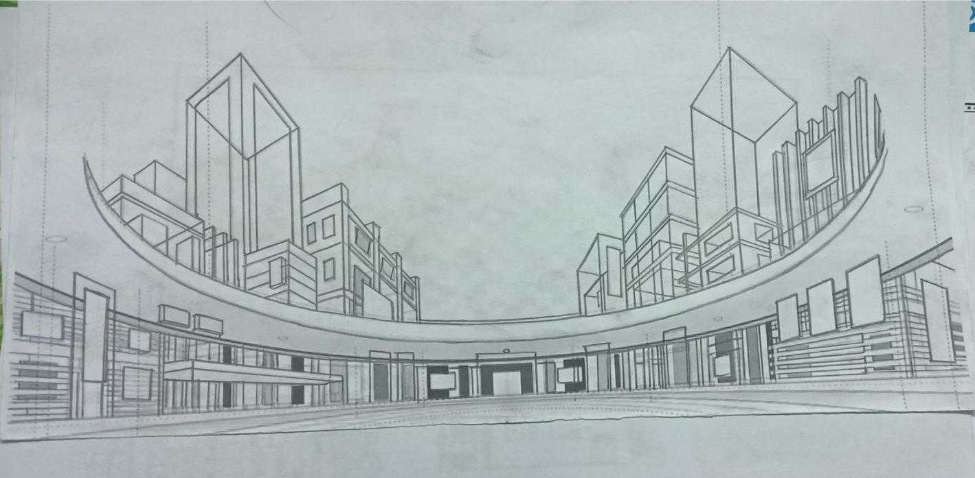Educational institutions to promote the schooling and further education of both adults and children. Two primary schools provide education for children between 3 and 14 years of age. The primary schools are located on opposite sides of the residential torus, guaranteeing close proximity between the youth student and their homes and families.

**HANDICAP ASSISTANCE**: In order to establish a friendly and cooperative environment for all individuals handicap assistance is incoperated in to every aspect of the settlements design elevators and ramps are installed in every building to provide maximum unstability and comfort. In addition the mars rower the martain off road vechicle and the pods of the pod monorail have additional room to accommodate for all individuals with disabilities.

**EMERGENCY DEPARTMENTS:** These small departments will provide emergency transportation will function as the public and fire department. It will also have rotation shelters and will be connected to the network around the settlement in order to inform settlers in case of an emergency and give instructions drills will be conducted regularly.

**STADIUM / PLAY GROUNDS**: Play grounds & ministadium for sports to the purpose to play includes all types of sports in the stadium.

**ADVENTURE PARKS:** Some like water parks the adventure parks are situated atman. The adventure parks includes.

1. FERRIS WHEEL2. ROLLER COASTER

3. BIG PENDULUM

4.FLYING CHAIR

5.PIRATE SHIP

6.BUMPER CAR

7.ROTARY OCTOPUS

**RELAXATION (COACHING CENTERS**) :Relaxation and coaching centers includes meditation, yoga, zumba, martial arts, dance, singing, coaching center to the people of ATMAN . To learn something new for extra curricular activities for senior citizen and for the people of any age the relaxation center helps them many ways.

**ANIMAL HUSBANDARY**: In animal husbandary the domestic animals will be there flesh eating animals like hen, goat, sheep will be present the food chain process of those will be continued for long to produce. Domestic animals can be cloned using techniques such as embryo splitting & nuclear transfer to produce genetically identical individuals.

**SPACE MUSEMES**:

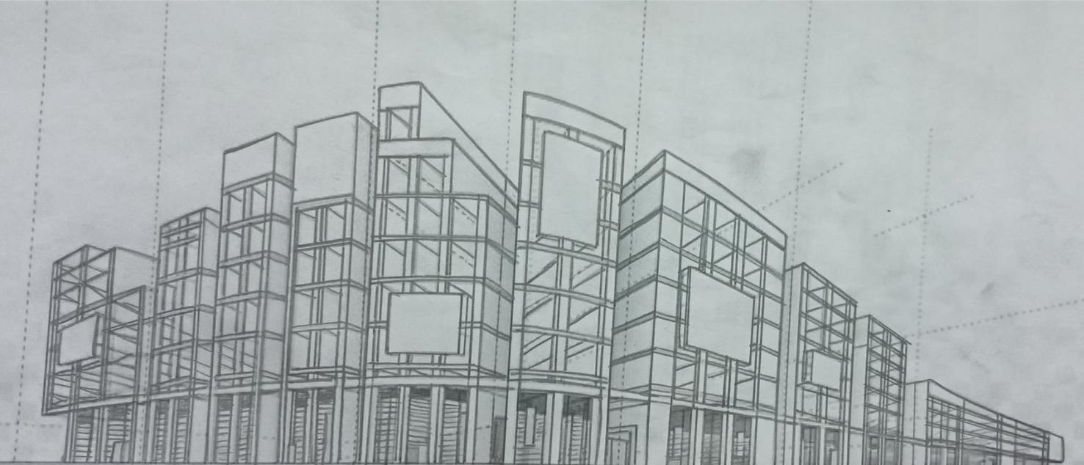The musem’s house thousands of artifacts showcased in exhibitions on eviation space exploration and planetary science the museum presents programs educational activities, lecturers and performance that reflect the amarican spirit and the innovation courage and optimisim that haveled to triumphs in the history science & technology of light. At the museum in ATMAN that accommodate large aircraft and space craft as well as entire collections and space artifacts.

|  |  |
| --- | --- |
| TORUS 1 | A=6890072.24 m² |
| TORUS 2 | A=6090816.496 m² |

**TORUS ONE**:

|  |  |  |  |
| --- | --- | --- | --- |
| **TYPES OF HOUSES** | **NO.OF HOUSES** | **AREA** | **PEOPLE** |
| STAR HOUSE | 228 | 164,160 m² | 43,200 |
| DUPLEX HOUSE | 440 | 132000 m² | 2640 |
| PAKKA HOUSE | 690 | 379500 m² | 4140 |
| NATURE HOUSE | 360 | 322560 m² | 2880 |
| IGLOO HOUSE | 156 | 638976 m² | 14,976 |

|  |  |  |
| --- | --- | --- |
| **NO.OF CONSTRUCTIONS** | **TYPES** | **AREA** |
| 5 | SCHOOLS/COLLAGES | 66,000 m² |
| 3 | HOSPITALS | 35,6000 m² |
| 4 | RESTAURANTS | 47,2000 m² |
| 4 | HOTELS | 56,000 m² |
| 6 | MARTS/BAKERYS | 46,500 m² |
| 8 | SHOPPING MALLS/THEATRES | 87,400 m² |
| 5 | PARKS | 80,200 m² |
| 3 | GROUNDS | 27,200 m² |
| 2 | ADVENTURE PARK | 172,580 m² |
| 1 | MUSEUM | 76,800 m² |
| 2 | RELAXATION CENTER | 77,240 m² |
| 1 | ANIMAL HUSBANDRY | 1,10,800 m² |
| 3 | LAKES | 1,90,800 m² |
| 6 | REPARING SHOPS/GENERAL STORE | 63,500 m² |
|  | TRAIN |  |

**TORUS 2**

|  |  |  |  |
| --- | --- | --- | --- |
| **TYPES OF HOUSES** | **NO OF HOUSES** | **AREA** | **POPULATION** |
| STAR HOUSE | 128 | 856410 | 25100 |
| DUPLEX HOUSE | 240 | 63200 | 1800 |
| PUCCA HOUSE | 390 | 15795 | 2578 |
| NATURE HOUSE | 180 | 162560 | 1611 |
| IGLOO HOUSE | 78 | 338976 | 8476 |

|  |  |  |
| --- | --- | --- |
| **NO OF CONSTRUCTIONS** | **TYPES** | **AREA** |
| 3 | SCHOOLS /COLLAGES | 33000 |
| 2 | HOSPITALS | 206500 |
| 2 | RESTARENTS | 274000 |
| 6 | HOTELS | 36000 |
| 2 | MARTS /BAKERYS | 24500 |
| 4 | SHOPING MALLS THEATERS | 48700 |
| 5 | PARKS | 50800 |
| 3 | GROUNDS | 17950 |
| 1 | ADVENTURE PARK | 102580 |
| 1 | MUSESUM | 56780 |
| 1 | RELAXATION CENTER | 67140 |
| 2 | ANIMAL HUSBANDARY | 89900 |
| 3 | LAKES | 90800 |
| 4 | REPARING SHOP/GENERAL STORE | 50100 |

**EMERGENCY CONTINGENCIES**

**Fire :**

Sensors located in module detect smoke.Hatches between modules shut to stop the fire from spreading.Emergency oxygen supplies&emergency rooms.

**Air Contamination:**

Sensors detect contaminant. Emergency oxygen supply and air will be filtered.

Water Contamination: * Backup waterloop is brought and contaminate is filtered.

Food Contamination: * Biosensors and Human specialists locate source of pathogen (Micro organism that cause disease to its host)

Power Failure: *All electric based systems are shutdown.Equipment failure: *Sensors locate source of power failure. Cyber Threat: *Anti virus program.

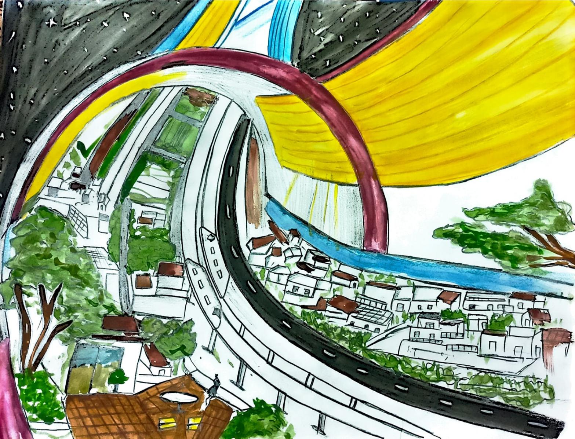

**CHAPTER-3**

**AGRICULTURE:**

Vertical farming particle forming with Tower Gardens is on the rice and right fully so we can grow a variety of plants without any soil and 90% less water it also requires 10x less space so you can do not more in smaller area. That means easily growing fresh herbs, fruits, vegetables and flowers both Indoor and out everything is grown in picked fresh the flavour is unbelievable

**Types of vertical forms**: Vertical forms in buildings buildings are re purpose for vertical farming but it's not necessary such buildings be used often depending on the requirements new buildings are also used to construct vertical forms.

**Shipping Container vertical forms:**

Old or recycle shipping containers are equipped with lightening vertically stacked forms controls and monitoring sensors such types of forms can save space and get a higher yield in the process

**Underground vertical form:**Also known as deep forms these types of vertical forms are built in underground abundant mine shops or any subterans environment. The constant and humidity means that they require less energy for heating as for water supply source can be used such also produced 7 to 9 more food convention form.

**TECHNIQUES OF VERTICAL FARMING:**

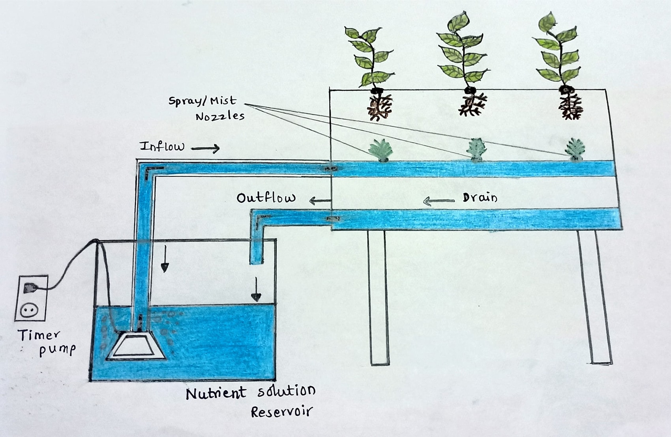

**HYDROPONICS**

Method of growing plants without the environmental soil here plant routes are submit in Magnesium nitrogen potassium calcium et cetera. Solution support routes improving chances of higher yield and revolving dependents on water 11 times yield compared to conventional forms one by 13 times less water. Hydroponics is the most widely remembering method in vertical forming,

**AQUAPONICS**

A slightly advanced method that hydroponics aquaponics integrated production of plants with that of Aquatic organisms in a closed loop system resembling nature itself.

**AEROPHONICS**

Like the name suggest Aero Phonics does not use mediums like solid or liquid instead it uses air to grow plants a liquid solution is used in air where the plants are located through which the plants observe nutrients it is the most suited method as it requires neither water nor soil and requires no growing medium.

**PHOTO BIOLOGY**

A plant Biology photobiology has explained how plants are able to discriminate between types of light as a function of spectrum intensity on duration interactions with molecules from living organisms help us can use light to improve plant cultivation. At a biological level there are two major ways light impact plants

1 light is an energy source required to power any plant metabolism and consequently only organisms that depend on plants as a food source herbivores

2 light acts as a maestro to give plants cues about their surroundings and crucial information that helps them anticipate transitions between day and night or transition between seasons

This translate into important changes at the level of plant and shape phinotypical or psychological changes in terms of light produced Chemicals inside plants phytocompounds that are of interest for agriculture and agromonic purposes

The field includes the study of photosynthesis photochemistry photosynthesis virtual processing circadian rhythms photo movement bioluminescence and radiation effect

**There are three basic photochemistry**

*First law of photochemistryThis law explains that in order for photochemistry to happen light has to be observed

*Second law of photochemistryThis law explains that only one molecule will be activated by each and that is absorbed

*Bunsen rascove law of reciprocityThis law explain that the energy in the final product of a photochemical reaction will be directly proportional to the total energy that was initially absorbed by the system.

**PHOTO BIOLOGY**

Plant growth and development highly dependent on light photosynthesis is one of the most important biochemical processes for life on earth possible due to the ability of plants to use energy from photons and convert into molecules such as NADPH & ATP to then fix carbon

dioxide and make it into sugar that plant can use for their growth and development. Photosynthesis is not only the plant process by light just photo and plant photo period are extremely important for regulation of vegetative and reproductive growth as well as production of plant secondary metabolicis.

**Photosynthesis**

Photosynthesis is defined as a series of biochemical reactions that to transform light energy 2 chemical energy and store it in carbon bonds of Carbohydrates as it widely known this process happens inside of the chloroplast of photo synthetic plant cells where light absorbing pigments can be found embedded in the membrane of structure is called Thylokoids.

There are two main pigments in the systems of higher plants chlorophyll a or b and contents photosynthetically active radiation(PAR)Due to the Limited amount of pigments in plant photosyntic cells there are limited range of wavelength that plants can use to perform photosynthesis this range is called photosynthetically active radiation p a r interestingly almost in the same as the human visible spectrum and it extends in wavelength from 400 to 700nm PAR is measured in micrometre per sec ____ and it measures in the rate and intensity of Radiant light in terms of micro moles per unit of surface area and time that plants can use for photosynthesis.

**Photo Biology active radiation PBAR**

PBAR is a range of light energy beyond and including PAR photo biology photon fluxPBF used to measure PBAR.

**Photo morphogenesis**

This process refers to the development of the morphology of plants which is light mediated and controlled by 5 distinct photo receptors UVR8 cryptochrome phytochrome photrophin and light can be control jenny processes such as leaves size and short elongation. Different wavelength of light produce different changes in plants red 2 for red light for example regulates stem growth and straightening of the seeding routes that from the ground some studies also that red and forered light increases the routing mass of tomatoes as well as the routing percentage of grape plants on the other hand blue and UV light regulate the and elongation of the plant as well as other psychological processes such as control and responses to environment stress finally green light was thought not to be available two plants due to the lack of pigments that would absorb this light however in 2004 it was found that green light can influence metal activity stem elongation of ink blanks and leaf expansion

**Secondary plant metabolites**

These compounds are chemicals that plants produce as part of their biochemical processes and help them perform certain functions as well as protect themselves from different environmental factors. Case some metabolic such as anthocyanins, flavour noids and carotinous can accumulate in plant tissues to protect them from UV radiation and very high light intensity.

|  |  |
| --- | --- |
| **NAME** | **QUANTITY FOR WHOLE SETTLEMENT** |
| FOOD | 7975440kg |
| MEAT | 3,120kg |
| WATER | 40ml |
| CLOTHING | 27,36,000M |
| ELECTRICAL APPLIANCES | 410400 units |
| MEDICINE | 144000 kg |

**AUTOMATION:**

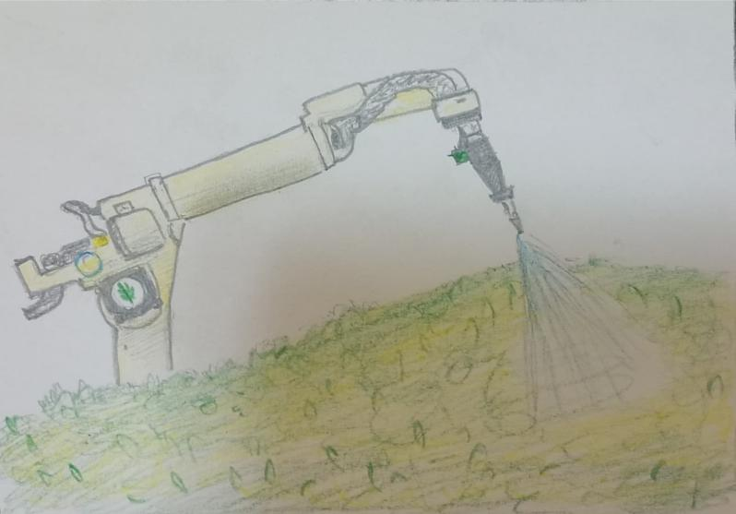Agriculture automation is the process of using various technology equipment to enhance and automate agriculture business this forming technology is intended to alleviate the labour intensive and time consuming agriculture operations that farmers all over the world face. Farmers may game more time and resources to invest in their properties with the aid of form automation and Agriculture Technology developments.

Autonomous tractors the autonomous tractor is the form equipment that can indeed be remotely operated or perhaps even pre program to provide a producer with complete autonomy. The autonomous tractor from rabbit tractor and value To Rok crop producer not just by lowering labour expenses but also by increasing overall efficiency and yield.

**Seed and weeding:**

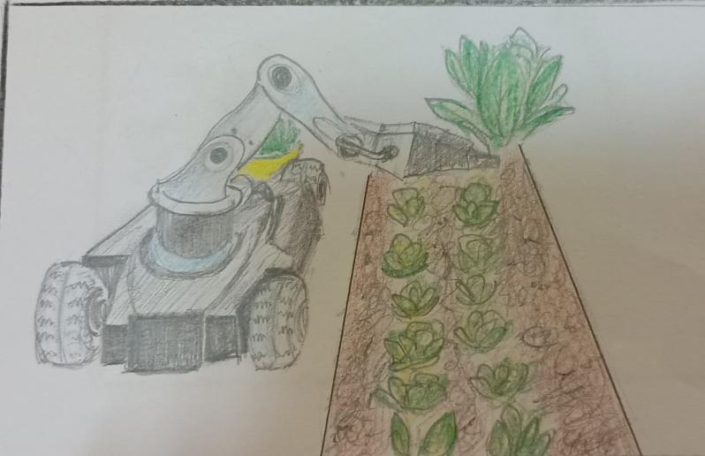

Feeding and weeding robots maybe program to target specific agriculture farming areas this may easily minimise labour and monotonous formed duties sowing new technology of computer vision weeding robots can be extremely precise and minimise pesticide consumption by 90%.

The technology uses computer vision and robots technology to accurately spray herbicides where and when they are needed. Farmers now have a new method for controlling and preventing herbicide resistant weeds.

**Drone Irrigation**

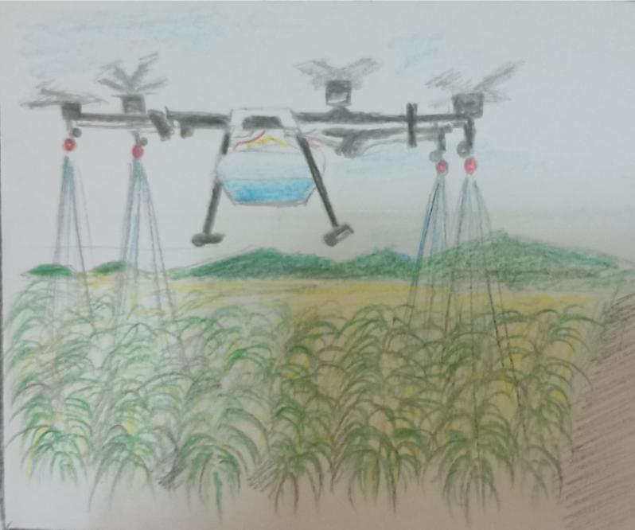 Cultivation of fruits and vegetables in agricultural land is a critical stage in ensuring the health and well being of the product throughout of its life cycle.

These drones are capabled comprehending and adjusting to form details Such as altitude plane varieties planted and even weather conditions when paired with monitoring technologies,these drones can easily detect particular areas of the form that demand more care and match these requirements

All of these characteristics make automation an excellent choice for agricultural business, particularly as farms expand in size . Agricultural farming traditionally required several repetitions and hard effort at a slowpace for planting irrigation fertilizing monitoring and harvesting a broad area of crops , However, a single robot may now perform all of these tasks with minimal reliance on human labor

**Benifits**

1.They can operate with fewer faults because of faster speeds and tighter tolerance

2.They produce fewer mistakes and work at faster speeds and quality3.On the farm the robots can cut pesticides consumption by upto 80% 4.Robots are more efficient in many sectors and can readily operate around trees rocks ponds etc

5. Automated agricultural technologies offer high quality items while lowering production costs6.Gantry robots can serve as fertilizer or liquid sprays, as well as an autonomous self control system that adapts to weather conditions.7.Automated cameras and sensors may detect weeds identify pests parasites or illnesses and detect other stressors Typically the sensors are selective and only spray on the afflicted region 8. Robots offer a strong return on investment by delivering effective solutions to replace human operators.

**NFTC ( Nutrient Fil Technique System)** The oblique platform will be provided with nutrient from the tank below . The flow of water will return to the tank through the orifice at the end of the tray, the water will be changed at regular intervals.

**Placement** . The platforms will actually have the form of a tube . They will be placed so as to form a right angled traingle, with the angle of inclination of the tubes of 45Â° the evacuated water will also be purified in different areas, sorted by the type of plant.

**Ebb and flow system**

The Ebb and Flow system will be used for plants like rice. The placement of the tanks and harvesting Robots will be the same as the ones used for the aeroponics.

**Storing and packaging** Food will be dried and packed by vaccum packing methods semiprocessed food seed will be stored in specified compartments under projected floors of agricultureal and resendtial tori to low temperature.

**Delivery and selling**

Conveyer belts will be used to bring food from basement storage areas to ground elevators in the connectors will transparent food from agricultural tons to residential tons food will be sold at retail outlets and restaurant, residents can also place orders themselves or by automated system for purchase of food from warehouse which will then be transported by robots.

|  |  |
| --- | --- |
| **ENERGY** | **QUANTITY** |
| CARBOHYDRATES | 41.7 |
| FATS | 49.7 |
| PROTEIN | 100.2 |

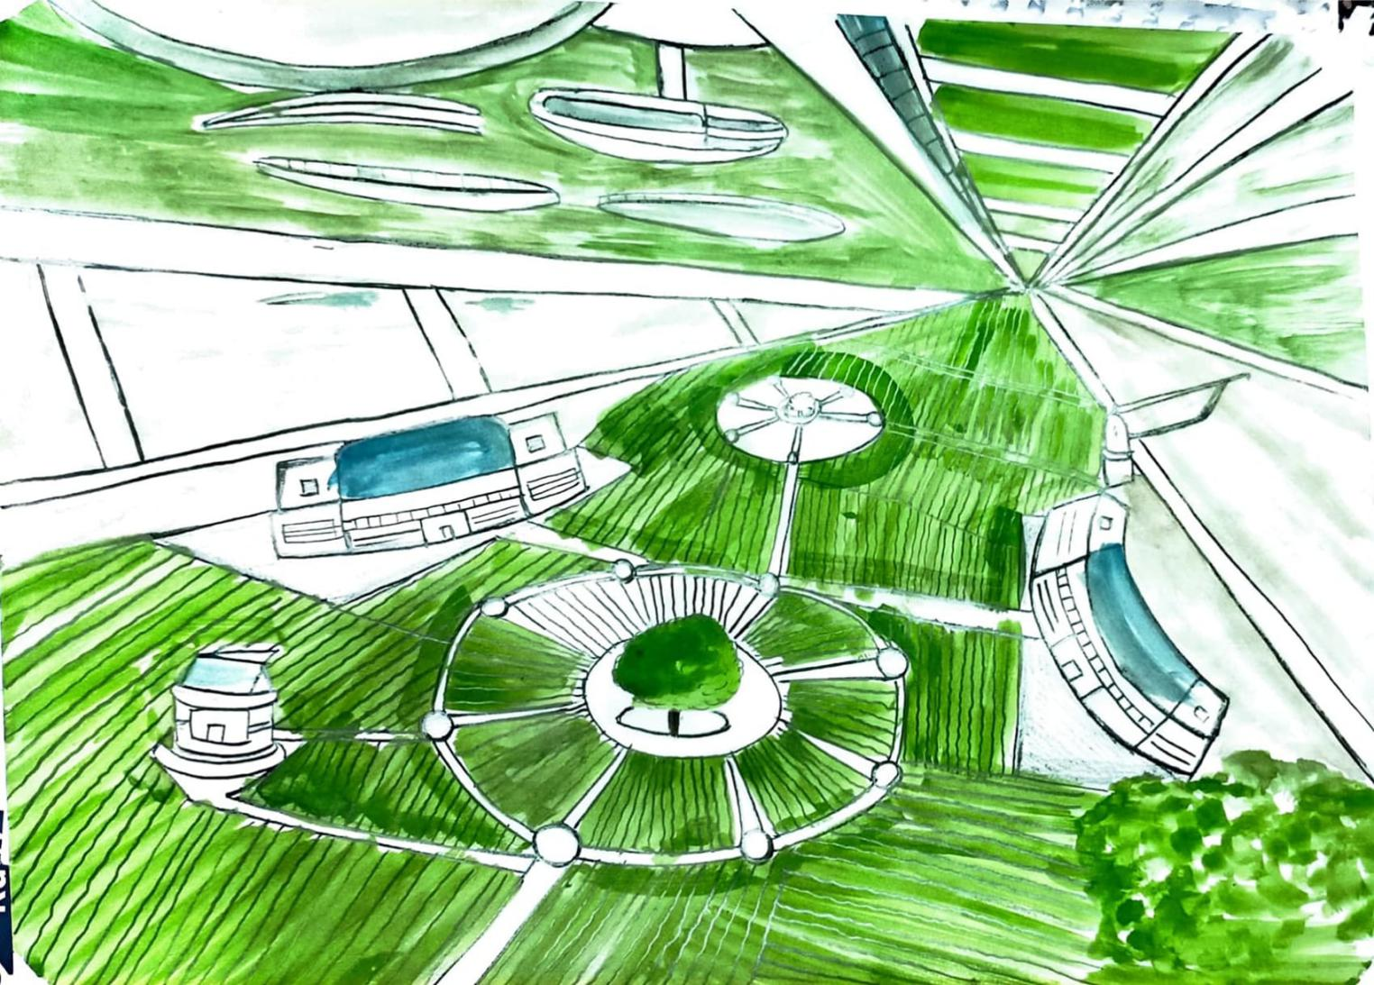

**CHAPTER - 4**

**TRANSPORTATION**

Transportation is the activity of taking goods or people from one place to another in a vehicle. Here in ATMAN we use transportation of air,land,track and space.

1.Internal Transportation

2.External transportation

**1. INTERNAL TRANSPORTATION**

The highly advanced transportation system called hyperloop is cancelled because of critics quickly pounced on the project’s problems and impracticals. Some argued the system would be pricier and require more energy than Musk had calculated, making the Hyper loop impractically expensive. If the hyper loop is succeed currently using Maglev may replaced as much as by hyper loop in our ATMAN Space Settlement

**MAGLEV**

|  |  |  |
| --- | --- | --- |
| **Torus types** | **Types of Maglev Train** | |
|  |  |
|  |  |  |
|  |  |  |
|  |  |  |
|  |  |  |
|  |  |  |

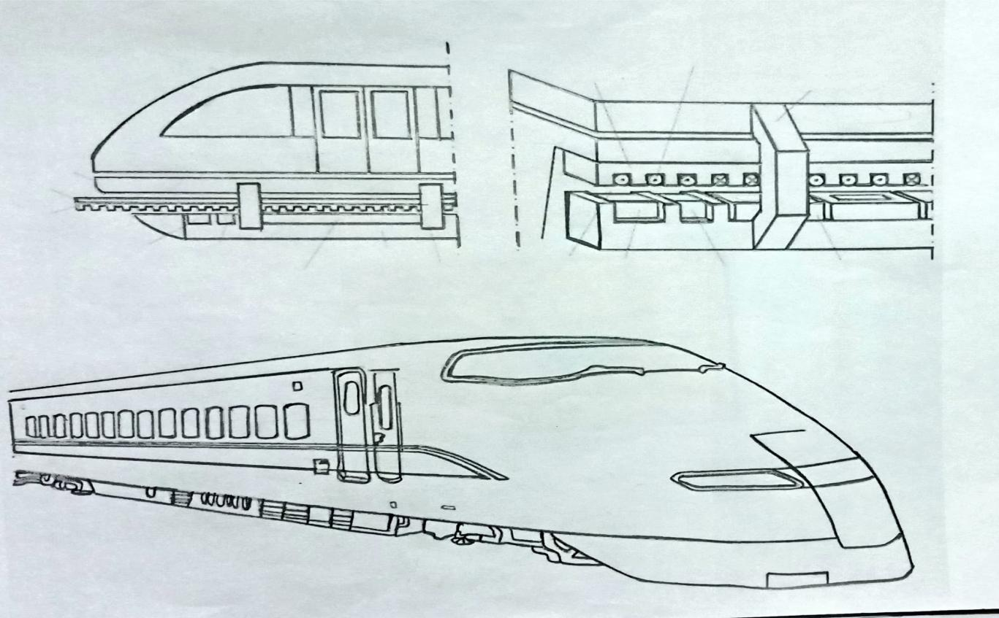

Maglev (derived from magnetic levitation), is a system of train transportation that uses two sets of ELECTROMAGNETS. Here we in ATMAN Space Settlement uses maglev for people transportation and goods also throughout the torus and trough spokes.

**Two sets of Electromagnets:-**

One set to repel and push the train up off the track, and another set to move the elevated train ahead, taking advantage of the lack of friction . Such trains rise approximately 10 centimetres (3.9in) off the track.There are both high speed, intercity maglev systems (over 400km/h or 250mph), and low speed, urban maglev systems (80–200km/h or 50–124mph) being built and under construction and development. With maglev technology, the train travels along a guideway of electromagnets which control the train's stability and speed

*SMART BICYCLES Researchers have developed an autonomous bicycle that can respond to voice commands due to a neuromorphic chip. In addition to recognizing voice commands, this chip includes hundreds

of thousands of sensors that help the bike avoid obstacles and maintain balance. This Bicycles works as a physical activity to the residents of ATMAN.

**MULTI DIRECTIONAL ELEVATOR**

With increase in population and restriction in space the need for tall building has increased exponentially. However current elevator technology interfere the efficient construction and use of skyscrapers. This review paper discuss about the working of rope free multi-directional elevator which could move both in horizontal and vertical direction. This multi system elevator are powered by electromagnetic induction system as a result magnetic evitation system which help the elevator car to move sideways as well in upward and downward direction. This technique eliminate the limitation caused by rope, which restrict building height and slow down the elevator car. It also reduces waiting time, optimizes cost and increase energy efficiency. This multi technique allows multiple elevator cars to fit into one shaft and move throughout the building in a loop. By using this technique user will experience shorter waiting

time.This transportation system is used in central hub this gives us easy access to move from one torus to another torus . And also used in malls,apartments etc.. in the Space Settlement.

**ENHANCED DRONES**

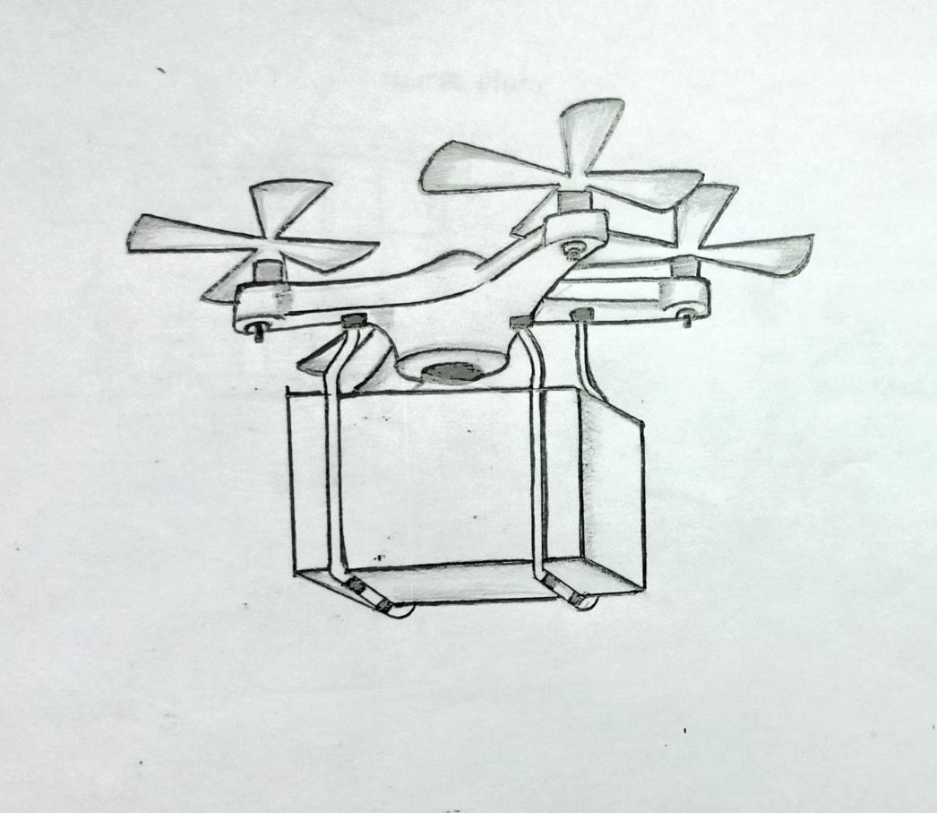

Drone technology continues to advance rapidly, especially regarding research and development of durable and lightweight materials, payload capacities, battery power, quieter operation, georeferencing tools, and sophisticated yet easy-to-use software that monitor flights in real-time and analyzes flight data.

* These enhanced capabilities expand the ways drones can be used for the best approach for responding to medical emergency scenarios,in our ATMAN Space Settlement.

*This enhanced Drones or flying robots are used for agriculture and military services.*It also used in , traffic monitoring and weather monitoring

*AERO X HAVER BIKEAero x hover bike is a type of aircraft which looks like a flying bike.it is created by aerofex. It can carry up to two people’s, rises up to 10 feet from ground, have weight of 785lb, length of 15 feetand travel with maximum speed of 45 miles per hour.It is much smaller in size and safer. This is used in the agriculture field

work, delivery and military services.- Free of traffic(Time saving)- used in racing games.

CYCLE VEHICLE:

It is a cycle type vehicle.It is useful too excercise purpose and also travel from one place to another , cycling is a good excercise.

When we cycling the cycle is in rest by support of stand and mechanical energy is converted in to electrical energy that energy is stored in a bathers,which is present at back side of the seat.When we go outside or travelling we use that stored energy that energy is converted in to electrical energy to mechanical energy.It is friendly cycling vehicle.It is best comfortable vehicle.

ELECTRIC VEHICLE:

It is simple vehicle .It uses electricity to charge the vehicle students used this vehicle to go to school or collage.Basket is attached at the front of the vehicle.It is used to carry the bags or books of the student.It is excellent and effective vehicle for the student's.Not only student's resident's also uses these vehicle.

RAMB CAR:

It travels on road and also in air .It is dual type vehicle.It can carry up to 4 people's.It rises up to 15 feet from the ground.On roads it travels normally in. In air the tyres will convert in to a propellers.It uses electricity to travel on roads.

AMBULANCE:

It is a ambulance.It contains first aid box for primary treatment.It also contain one robot which checks the patient and gives the treatment to prevent diseases

If it is emergency situation and robot can't find the solution to that particular disease it will move to the hospital for better treatment.

It is a construction spacecraft.It has storage which stores the materials that are needed for construction.It construction the settlement.It fixes the settlement where any damages occured.

This ROBOT is used for cleaning and mopping the houses .It is also used for watering the plants.It also pairs the household materials when damages occured.

EXTERNAL TRANSPORTATION

The Transportatiom used to go out of the settlement for mining purposes,space trips,earth visits etc....

SPACE CRAFTS

A spacecraft is a vehicle or machine designed to fly in outer space. A type of artificial satelite, spacecraft are used for a variety of purposes, including communication, Earth observation, meteorologu, navigation, space colonization, planetary exploration, and transportation of humans and cargo.Using ion thrusters space craft’s movi in space.Ø - SUB ORBITAL SPACE FLIGHT is a type of Spacecraft used to enter in space and then return to the planet, without going out of orbit.Space craft used for human spaceflight carry people on board as crew or passengers from start or on orbit (space stations). Only,whereas those used for robotic space missions operate either autonomously or telerobotically .Robotic spacecraft are space.

probes -space shuttle - space probe -space crafts

i. Crewed space craft

ii. uncrewed space craft.

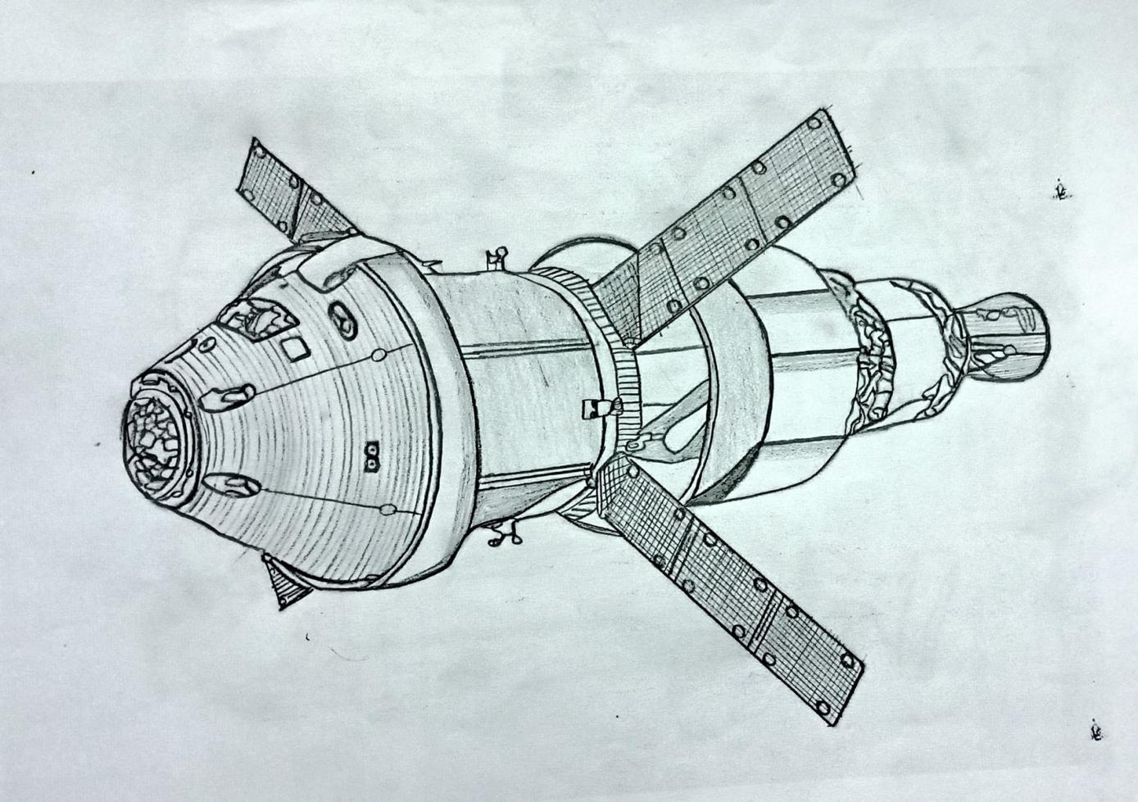

**CHAPTER -5**

**WATER EXTRACTION**:

Mass require systems that can create breathable air from their harsh surroundings and chemistry plays a important role.

Currently uses an absorption method to remove carbondioxide (CO2) from the air. The absorption is accomplished in a chemical reaction using a sorbent called lithium hydroxide (LiOH) . This method relles on the exothermic reaction if lithium hydroxide with CO2 to create (Li2CO3) and (H2O). Lithium hydroxide is an attractive choice for space light because of its high absorption. Capacity of carbondioxide and small amount of heat produced by the reaction a device called the contaminated control cartridge,which contains lithium hydroxide (LiOH) removes carbondioxide (CO2) from the air. This process represents following eqn.

eqn()

1. Using the mass of CO2 captured by your filter ditermine how much lithium hydroxide each of your filter catridges would need in order to efficiently produce system.

**HYDROGEN FOR FUEL EXTRACTION**:

Liquid hydrogen has been used as a fuel in space technology for several decades with higher density and lower potential risks in terms of storage pressure compared with the compressed gas.The active martian water cycle the pressure of shallow water and soluble perchlorate

salts in the martian soil enables the production of hydrogen fuel &life support oxygen on Mars through electrolysis.

**OXYGEN EXTRACTION**:

**METHOD:1**

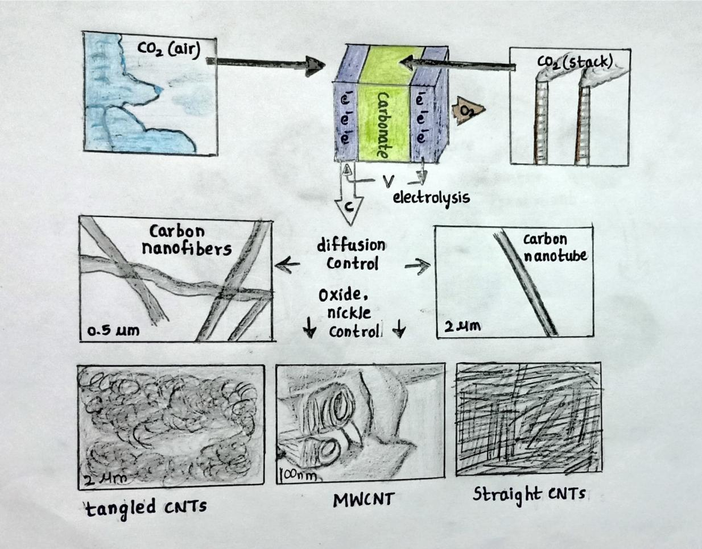

Hydrated silicates yield H20 molecules through minor heating to 100°C,the settlement collects the water as a source of water and as a source of oxygen through electrolysis

And the transformation of CO2 in to low defect (straight)and higher defect (tangled) CNT materials for use in both lithium-ion and sodium ion batters using the step process.Thses batteries show excellent performance and durability with no capacity fade measured in over 2.5 months lithium ion and sodium ion Devices, respectively.Control on the defect in Li-ion cells and overcome the bottleneck of 30_40mAh/g.capacity in sodium -ion cells and overcome the bottleneck of 30-40mah/g capacity in solution-ion cells that is associated with carbon materials.This provides to scale this step technique to levels of industrial Co2-containg smoke stacks.

|  |  |  |  |
| --- | --- | --- | --- |
| **GASES** | **PERCENTAGE** | **PRESSURE (KPA)** | **QUANTITY (moles)** |
| NITROGEN |  | 26.6 KPA |  |
| OXYGEN |  | 22.7 KPA |  |
| CARBON DIOXIDE |  | 0.003KPA |  |
| WATER VAPOUR |  | 0.001KPA |  |
| ARGON |  | 9.9KPA |  |
| METHANE |  | 0.00018 KPA |  |

**METHOD 2:**

**MOXIEMODULE**

Walking around the mars surface filtering all the CO2 out the maintain air I trying it in to oxygen so that for future mannered landing er wouldn't have to bring stored oxygen up.

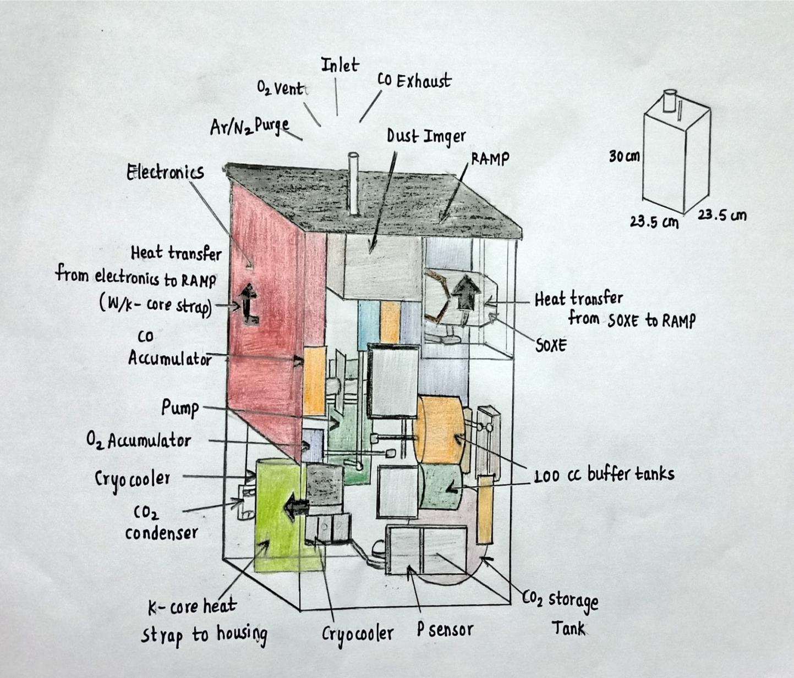

**WATER MANAGEMENT**:

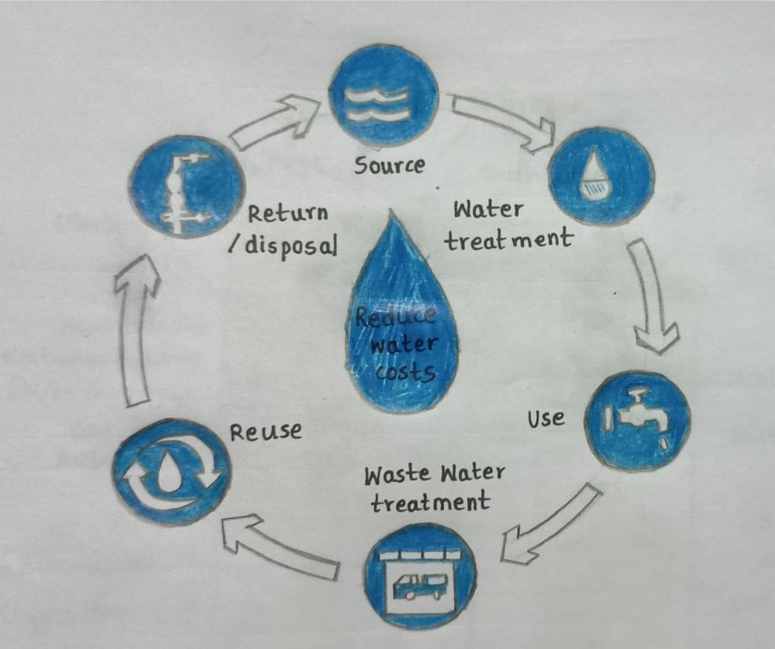

Water is one of the basic and most essential requirements for any human settlement.

A human can live without water for maximum 3 days.Since i our settlements water plays a crucial role.And water quality is very important for the resident's health so it is neccessary to provide it as pure as possible.Industies,agriculture sectors needs much water for the development.Water is supplied through pipes from the water resource plants.Where it is filtered in several ways.Every resident will provided water through pipe lines and the waste water collected at another pipeline.Industries also require water for the production of any food items or other.Agriculture requires water for the production and growing of the crops.Water will be extracted from polor ice caps of mars by evapouracting water and condensing it.

And this water is transported to the large tanks propelled by ion thrusters.Then,it will bw distributed to all the toruses based on their usage of the water.Each torus has large water tanks from which they receive water supply.

Resdential sectors receive water and agricultural receive watch from different tanks constructed in their respective regions.

**WATER TREATMENT PLANT:**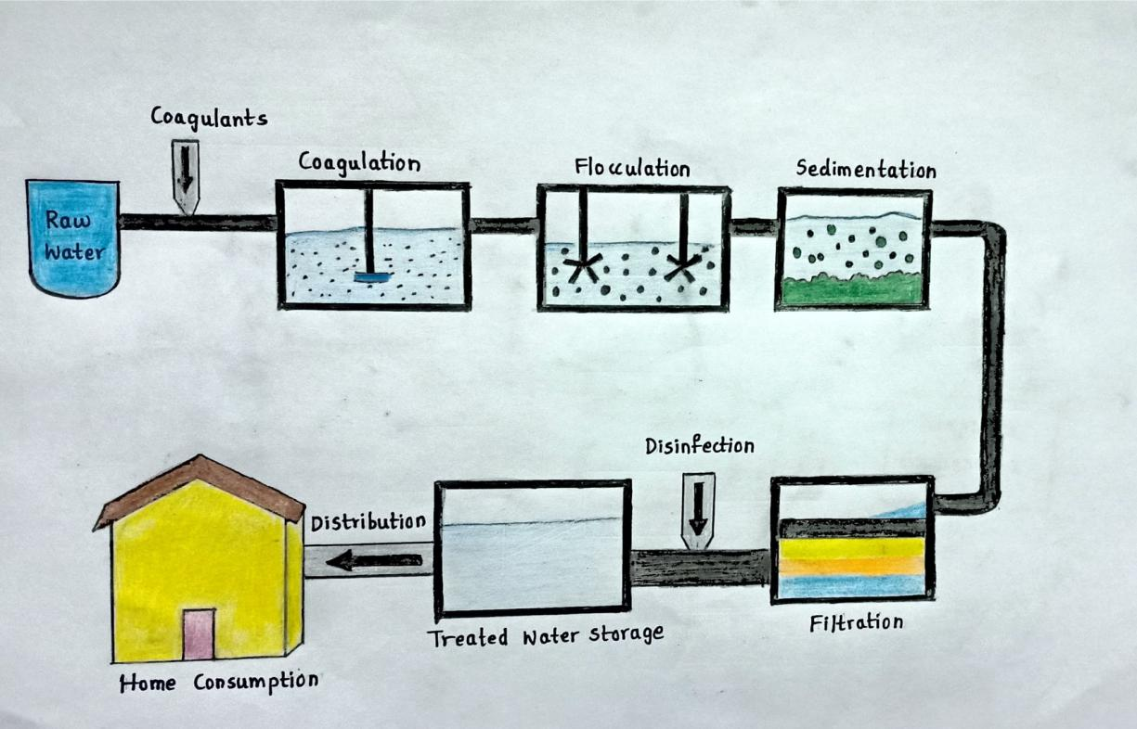

Coagulation,floculation,sedimentation,filtration and disinfection.

**COAGULATION**:

Dunning Coagulation,chemicals with a positive charge are added to the water.

Two positive charge neutralizes the negative charge of dirt and other dissolved particles in the water.When this occurs,the particles bind with the chemicals to form slightly larger particles.Common chemicals used in thsi stepinclude specific types of salts,aluminium or iron.

**FLOCULATION**:

It follows the coagulation step flocculation is the gentle mixing of the water to form larger,heavier partiles called flocs often,water treatment plants will add additional chemicals during this step to help the flocs from.

**SEDMENTATION**:

It is are of the steps water treatment plants use to seperate solids from the water.During sedmentation flocs settle to bottom of the water because they are heavier than water.

**FILTRATION**:

Once the flocs have settled to bottom of the water the clear water on top is filtered to seperate additional solids from the water.During filtrarion,the clear water passes through filters that have different pore sizes and are made of different materials(Such as sand,gravel and charcoal).These filters remove dissolved particles and germs,such as dust ,chemicals.parasites,bacteria and viruses.Activated carbon filters also remove any bad odors.Water treatment plants can use process called ultrafiltraction in addition to or instead of traditional filtration.During ultrafiltration on,the water goes through a filter membrane with very small pores.

This filter only lets through water another small molecules(such as salts and tiny charged molecules)

Reverse osmosis is also another another filtration method that removes additional particles from water.

**DISINFECTION**:

After the water has been filtered ,water treatment plants may add one or more chemical disinfectants(such as chlorine,chloramine or chlorine dioxide)to kill any remaining parasites,bacteria or viruses.

To help keep water safe as it travels to homes and buseinesses,water treatment plants will makesure the water has low levels of chemical disinfectant when it leaves the treatment plant

UV light and Ozone work well to disfect water in the treatment plant ,but these disinfection methods dont continue killing germs as water travels through the pipes between the treatment plants and your tap.

**ANAEROBIC DIGESTER:**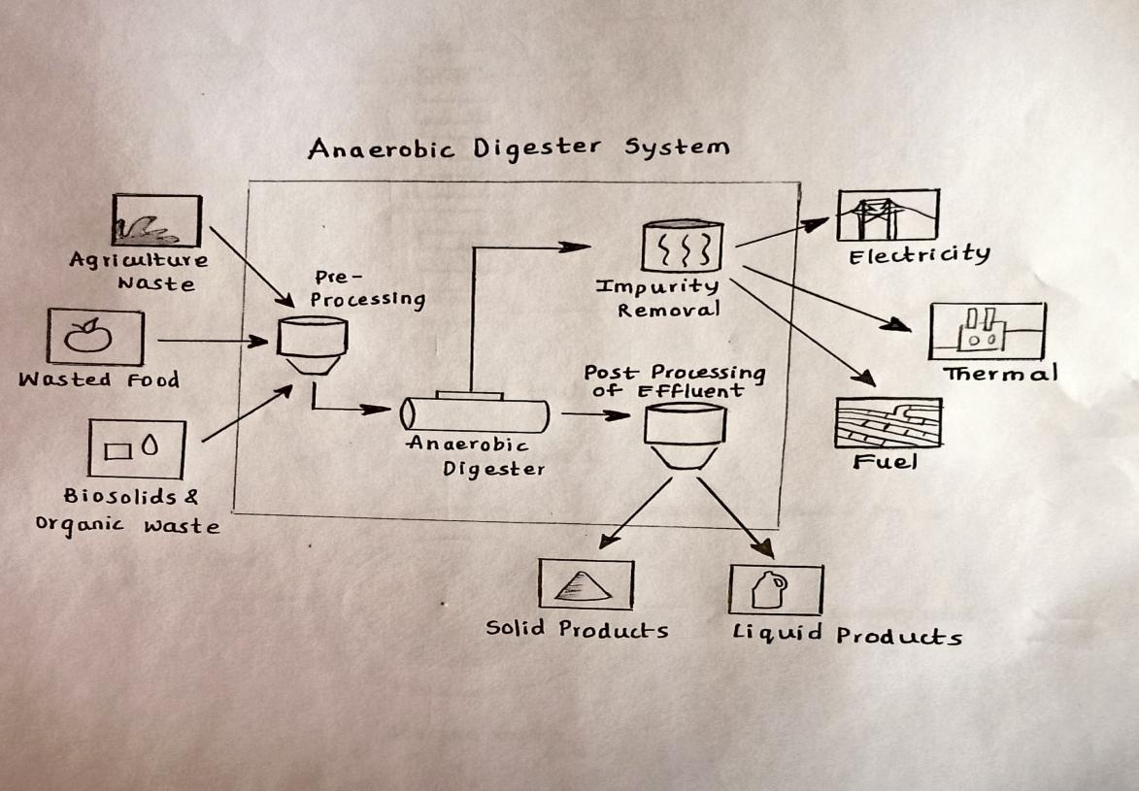

ALL sewage will first pass through a device known as an anaerobic digest special bacteria that survive without oxygen consume the waste and convert in into sludge,methane,and other guses sludge,gases and unpurified waste water will then enter a chamber known as super critical water oxidizer or SCWO.

The SCWO heats the by products from anaerobic digestion with unpurified water under extreme pressure by anaerobic digester fuels a fuel cell to power the SCWO.This fuel cell is also a backup power source.

The nitrates,minerals and salts that come out of SCWO are dissolved in water to make the nutrient solution sprayed at plants in aeropanic growth chambers.

They can alsso be used to feed algae and shellfish.

The water aoming out of SCWO is unappetizing to humans because it has been mechanically purified from feces and unne.

This water will be used in agriculture,aquaculture.

Drinking water will obtained through addition filtration process that was special plants such as grass and bmboo to clean the water and give natural taste.

|  |  |
| --- | --- |
| USAGE | AMOUNT (LIT/YEAR) |
| RESIDENTIAL |  |
| INDUSTRIAL |  |
| AGRICULTURE |  |

**WASTE MANAGEMENT**

The waste materials in the settlements should be properly recycled . Various sectors enerate different types of wastes . Recycling will have to play an important role in waste management . Organic wastes, Food waste, Agriculture waste, Animal waste, Contaminated water are the types of wastes that produced in our settlement . Paper , plastic metals and glass can be recycled, with an efficient, a little amount of storage space will be needed for waste.

We have two types of choices for non-recyclable wastes , either burning the waste or releasing it to the outerspace. Burning the waste will certainly help the storage aspect and carbon dioxide produced can be the plants for photosynthesis and non comn=bustable mateials will be released into out space. But excessive burning of wastes may affect the settlements.

Household waste gathered by trash collecting robots.

Food wastes household waste are recycled (or) decomposed with the help of microorganisms . Organic materials can be recycled with the help of composting, compoost can be used as fertilizer in agriculture. For sootechnic solid waste we use bacteria and worm , together with inorganic substances, to obtain again soil and nutrments that were used in int process of growing and rising.

Materials as plastic , aluminium and glass must be deposit in special places colected and melted.All non-biodegradable products shall be collected and recycled via a technical called thermal depolymerization. In this technique complex organic molecules are converted into simple ones by applying intense pressure are converted into simple ones by appling intense pressure and heat and produces useful crude oil and glass.

Non-organic waste includes materials that are neither carbon based nor metallic. Examples include glass,semiconductors and certain types of polymers. Recycling those materials is the most difficult . Non organis materials can also be incinerated in a swcond SCINO purposed just for inorganic waste . The biproducts of this willbe basic inorganic compounds from which new products can be made.

**Artificial Clouds:**

An artificial cloud in the cloudless atmosphere at a temperate below 0 degrees c was formed by introducing pellets of Dryice into air containing more water vapour than would be present at the saturation point with respect to ice.

Three conditions are needed to form an anthropogenic or artificial cloud.The air must be near saturation of its water vapour.

The air must be cooled to the dewpoint temperature with respect to water to condensation nuclei ,small solid particles.

Where condensation/sublimation starts.

**Cloud Seeding Methods:**

Cloudseeding is the process of spreading either dry ice or more commonly,silver Iodide aresosols,into upper parts of clouds to try to stimulate the precipitation process and form rain.

It uses planes to spray clouds with chemicals to condense smaller particles into larger rain droplets.

Cloud seeding operations cost much less than the desalination process.

**The artificial rain on our settlement make people to experience earth like environment.**

**WATER TRANSPORTAION**

Water is a valuable resource.It should be protected and used potentially.We will get from asteroids and also we will produce it at the lunar base.Drain water is collected and purified.Waste water is recycled as discussed in section of water recycling.Thus the water is supplied to agriculture, industrial nd residential sectors.Firstly,water is sent to each sector through pipes.At the end of the day,the used water is purified and stored.Water for industrial processes is sent to the respective area .Again the used water is purified from the industrial sector.How much amount of water needed for a particular sector is determined once in a week because the process involved in the industrial sector many change and for agriculture depending upon the irrigation techniques water is managed.

**CHAPTER-6**

**RADIATION**

--> A comprehensive study on radiation shielding characteristics of Tin-silver,manganin-R,Mastellogy-B,Hastellogy-x & Silver-p alloys.

--> Alloys that can be replaced lead and it’s derivatives in terms of radiation shielding.

-->New alternative studing material must have optimum properties that should be present in a protective material.

-->This focused on the determination of the radiation shielding characteristics of 5 different alloys named

Tin-Silver

Manganin-R

Hastellogy-B

Hastellogy-X

Silver-P

The photon interaction parameter’s

µ,µm,X1/2,Zeff,Neff,RPE that give significant information about the radiation shielding capacity of the materials were calculated for the alloy in the energy range from 30 to 1333 kev.The narrow beam transmission geometry was used to determine these parameters accurately and was adjusted such that the error rate is minimized.The present samples were irradiated with photons of nineteen different photon energies emmited from seven different radians (241An,133Ba,109Cd,152Eu,22Na,137Cs,60Co) photo intensities were measured by using 2 different detectors si(li),and NaI(T) for convenient photon energy regions.

Alloys found on Mars and there uses niobium a metal used in producing super conductor and specially steels,lithium and neodymium and europium for telivision monitors and energy efficient LED LIGHT BULBS

Mars that is the region which contains a group of gaint volcanos is considered to be a large igneous provinces (LIDS) such places are sources of nickel, copper,titanium,iron,platinum and chromium.

GYPSAM

GYPSAM is used as fertilizer.It has excellent fire resistance and great durability.It used to manufacture cement

MAGNESIUM

Magnesium is used by scientists in medicine magnesium is often used in atmosphere industry in the form of alloys .It is widely used in electrolysis industry's and military equipment.

ALUMINIUM:

Aluminium is used in aeroscope industries.It is key materials in manufacturing of cars ,trains,planes.Aluminium is used to make electrical conductors electrical companies.Aluminium is used in production of solar panels.

IRON:

Iron is used in making magnets iron is used as catalyst to speed up reaction.It is used to produce building tools and materials iron isnused to manufacture machine's.

CHROMIUM ALLOYS:

It is useful in aerospace industry . Chromium alloys are used in production of architectural fittings.It also used in production of engine components.

**DEFENCE**

DEFENCE:

MILITARY

ROBOTS

Military force on ATMAN Is empowered by the government to protect civilians and their property and also work for the defence.

The people will stay safely in the settlement by the defence department.

The military force department takes up the following activities:

1.Protection against invader and silent attackers.

2.Space object, astroid protection.

3.checking the planet.

DISASTER PROTECTION:

In case of any mishap like a fire accident,breakage of any spoke or triangulous, terrorist activity blasts,etc.. relief and reuse military come in to action.

**CHAPTER-7**

**POWER**: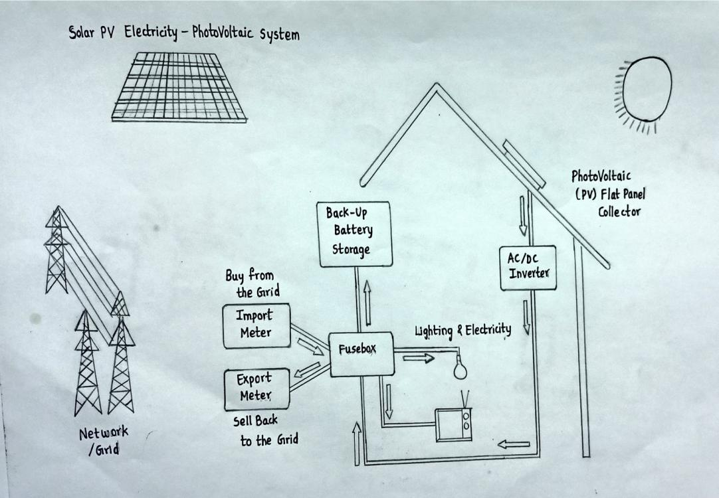

The electrical system of the settlement is critical resourse.

Below it allows the crew to live comfortably and to survive life,so we uses solor cells to directly convert sunlight to electricity.Large number of cells are assembled in arrays to produce high power levels.This method of harvesting solor power is called photovoltaics.The process of collecting sunlight,converting it to electricity and managing and distributing this electricity builds up excess heat that can damage space settlement .This heat must be eliminted to reliable operation of settlement in orbit.The power system uses radicator to dissipate the heat away from settlement.The radiators are shape from sunlight and aligned toward the cold void of deep space from solor sattellites,the power will be consumed to use.

On the other hand,we use nuclear power plant for generation of power.

**WIRELESS POWER TRANSMISSION**:

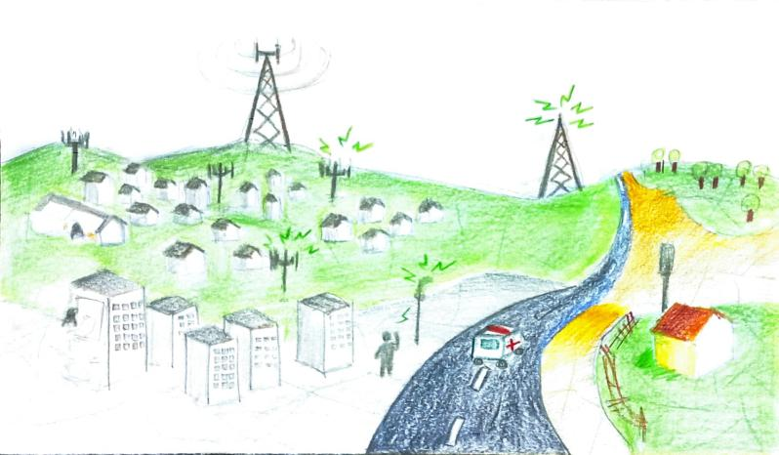

Wireless Power Transmission is an updated technique of power transmission without using any wires in the medium.A wireless transmission transfers power from the generation station to the consumer without using lowers and transmission lines.Wireless power Transfer(WPT) is the process where eletrical energy is transmitted from a power source to an electrical and across an air gap using induction cells.Tese cells produce an electromagnetic field that sends energy from a charging base station (transmitter) to a coil on a portable device (receiver)with complete galvanic isolation.

The receiver coil takes power from the electomagnetic field and converts it into electrical power.

**WORKING OF WIRELESS POWER TRANSFER:**

*Wireless power transfer works on the priciple of electromagnetic induction.

*A transmitter placed on the generation side generates flux to link with the receiver end.*At the consumer end,we will place a receiver it receives the flux and converts it with electricity.

*It will be used for a permissible distance,by using solor power sattellites we can transfer power any where in the world.*In the solor power sattellite transmission,we just need to place a transmitter at the sattellite end.We can place receivers wherever need power on the earth.

**Wireless Power Transmission through solor power sattellites:**

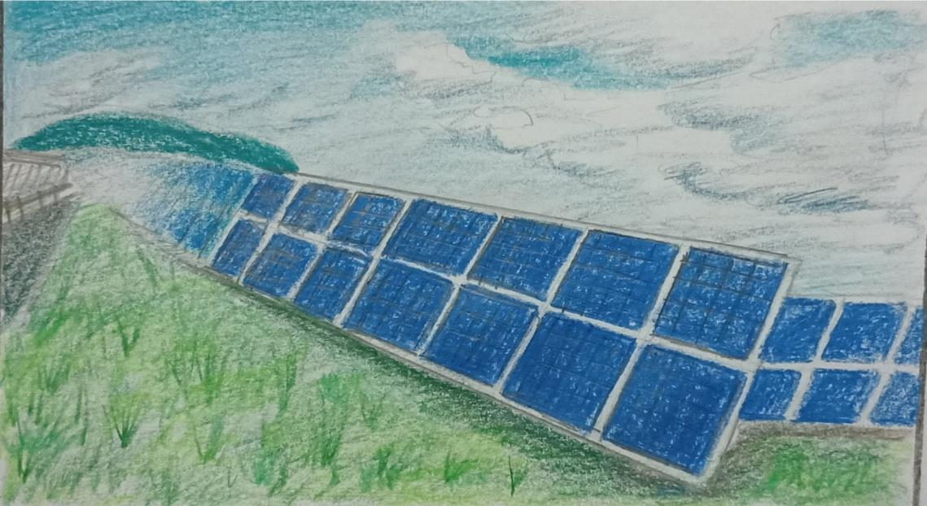

Solor power transmission using solor sattellites was first introduced in the 1970s.The solor sattellites generate power using their solor pannels by using the sunrise 24/7.

And the power generated will be transmitted by a transmitter in the form of microwaves and it converts the received waves into electricity.

**NUCLEAR POWER PLANT**:

Nuclear power is the use of nuclear reactions to produce electricity.Nuclear power can be obtained from nuclear fission, nuclear decay and nuclear fusion reactions.

The electricity for the settlement is supplied by this nuclear power.The usage of nuclear energy will be very beneficial.Our nuclear plants use enriched uranium for nuclear fission.In the nuclear reactors,fission will be carried out a the nuclear reaction type.Nuclear fission is the breaking of a nucleus into two or more smaller nuclei of similar mass.Because fission on reactions release huge amounts of energy,they are used to generate electricity in nuclear power plants.

**Nuclear energy is released through three processes:**

Nuclear fission, Nuclear fusion and radioactive decay .But in our settlement we use only two of the above processes i.e, nuclear fission and nuclear fusion.The energy coming from nuclei can be used to heat a liquid or gas to run turbines in a nuclear power plant ,producing electricity .That electricity is stored and further supplied to our settlement.

|  |  |
| --- | --- |
| **ELECTRICAL USE** | **AMOUNT REQUIRED (MW)** |
| **RESIDENTIAL** | **210 mw** |
| **COMMERCIAL** | **90 mw** |
| **INDUSTRIAL** | **180 mw** |
| **AGRICULTURE** | **120 mw** |
| **PRODUCTIVITY OF SOLAR CELLS** | **460 mw** |
| **PRODUCTIVITY OF SOLAR SATELLITES** | **300 mw** |
| **PRODUCTIVITY OF NUCLEAR POWER PLANT** | **160 mw** |

**INDUSTRIAL SECTOR**

Low g industrial tunes is the hub of small and medium industrial productions of mars bases and future mars machines. For instance the undeployed prefabricated bases for mars exploration would be made in this tunes.

This tunes also process material coming from phobas and deimos processing them into semi assembled components which will be sent to the zero g industrial area for heavy manufacturing and/or fully assembled products mars mapping satellites to other planets, rovers communication robots for earth to mars or settlement to mars ventures and maintainence of robots for the settlement itself.

**SETTLEMENT CONSTRUCTION** :

This industry & agriculture sectors alone only in 1 tunes.

This cultivation process beside the industry which they belongs.

|  |  |
| --- | --- |
| **TYPES OF INDUSTRIES** | **% OF PRODUCTION** |
| **TEXTILE INDUSTRY** |  |
| **MILLS** |  |
| **ROBOTICS INDUSTRY** |  |
| **HOUSEHOLD INDUSTRY** |  |
| **FOOD INDUSTRY** |  |

**MEDICAL INDUSTRY:**

The studies have shown that medicines manufactured in space have special properties and can cure such diseases which were earlier uncureable.Our settlement will manufacturing medicine's

Disease like AIDS and CANCER Can be treated with aid of micro gravity crystal growth.

MATERIAL INDUSTRY:

To construct houses ,malls, restaurants etc we need material.These material will manufacture at the materials industries.It also provide the materials to manufacture the robots,etc

It is one of important industries in our settlement .It also provides the clothes etc.

FOOD INDUSTRY:

Food industries are providing units of food after agricultural units.Raw materials from agricultural fields are transported to food industries eatbale conversion of raw material to eatable food takes place in food industries.

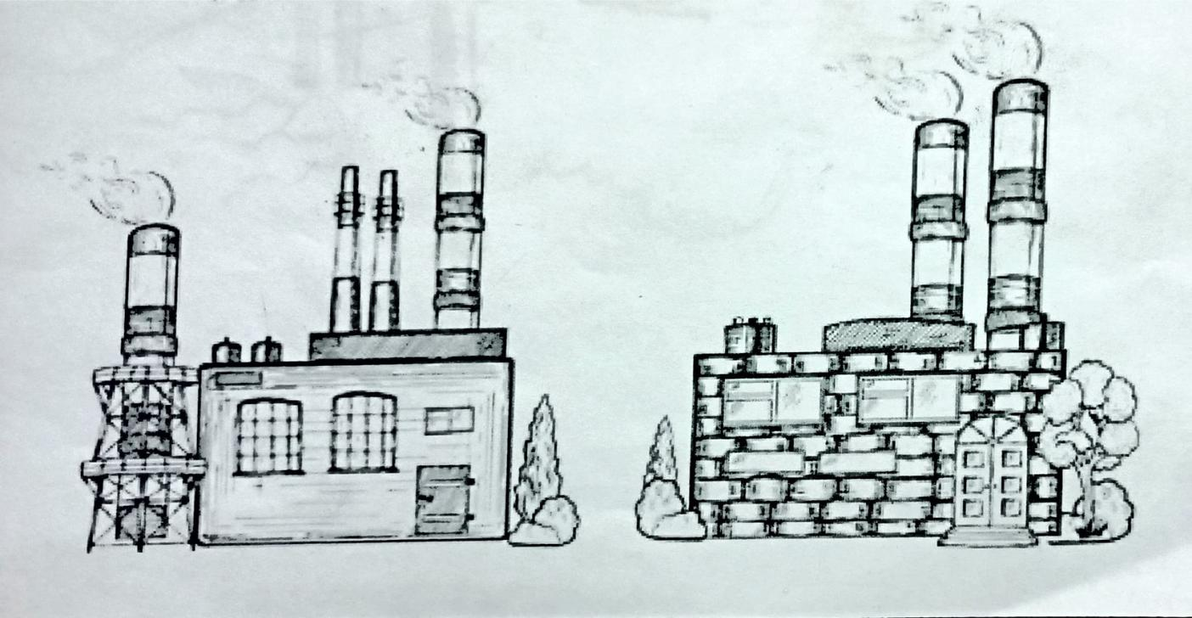

**CHAPTER-8**

**RESEARCH**

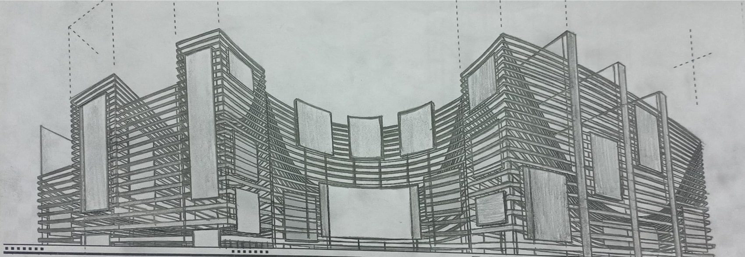

The most apparent reason to conduct research is to understand more research helps us to know more about the space and resources available there. The research process create new opportunities for learning and progress.

In our settlements research plant for all the types of procedures include nutritional agricultural chemical defence and technological research.

Nutritional research includes testing of plants and cloning of the plant for high yield in production and to upstand the settlement environment and new technological fertilizers pesticide.Chemical research includes new type of material generation and medicine research,chemicals that control environment within the settlement.

Mining related research to study about the elements to get from the extraction process and figure out the special characteristics and their properties, that will help in settlement development defense research includes various types of Defense material and robots designing and researching technologies research also done for better database of the settlement

High level programming designing and new types of Softwars that help the settlement to make into fully stable and protective.

Space research is more important for our settlement to examine the outerspace environment. For the prediction of asteroid attacks and other disasters space research expiration brings a bunch of benefits to our settlement in the technological way. It's about understanding loss and secrets of our universe.

SPACE SUITS:

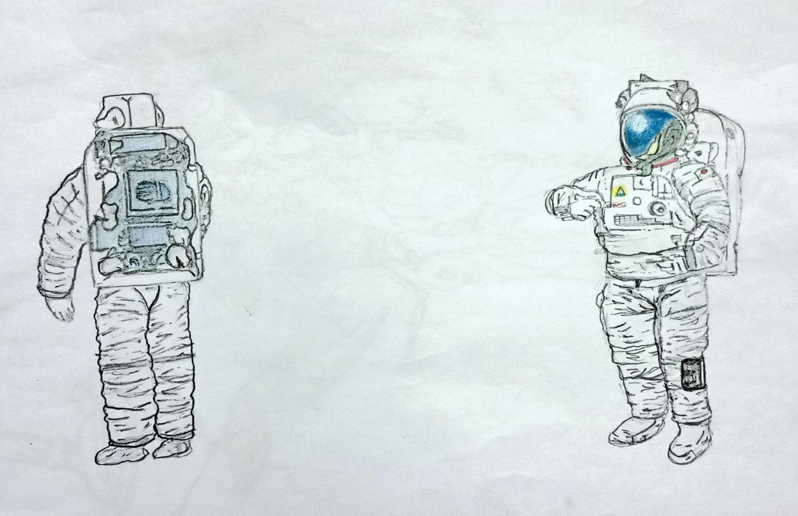

It applies the stable

pressure against the skin.

• It provides mechanical

pressure rather than the

air pressure.

• In space man cannot leave

more than 15sec without

a space suit .human flesh

will be expanded to twice

the size of him/her in

vacuum. This can be

counteracted through the

mechanical pressure which

is provided in the suit.

• In space without a space suit man will have consciousness only for

15 sec. So, man requires oxygen to breathe. So, a helmet is used

with the suit. This provides o2 and protect the ears and eyes.

• The minimum pressure required for a human to live is 17.3kpa (130

mm of hg).

• The pressure is applied on the head by the helmet rest of the body

is pressurized by the elastic effect of suit.

SMALL SATELLITES:

Small satellites becomes common minaturized satelites allow for cheaper desings & advancements in industrial technologies enable mass production wireless communication networks and for scientific observation data gathering and monitoring the Earth using the GPS.

Space inventor utilizes small satellites modules.

Edurovot develops nanosats for secure communication.

ADVANCED SPACE MANUFACTURING:

Space manufacturing adopts innovations technologies to improve space products and services with the advent robotics,3F printing,kight-based .

MANUFACTURING INNOVATIONS

REUSABLE LAUNCHED VEHICLES

SPACE SHUTTLES

SATELLITES SENSORS.

Moments manufacturers reusable rockets for public transportation.

ADVANCED COMMUNICATION:

At its simplest space communication rely on 2 things

A.Transmitter

B.Receiver

Thorium space technology develops ultra-flat interference free antena arctic space technology decreation processing power for ground states .

Space traffic Management:

All the men made LEO sattellites includes rocket trusters decrellet sattellites tiny fragments of debries from collisions and expressions.All thr debries are used to explore and travel clear space removes satellites relies.

Orbit gaurdience develops low cost active debries removal technology.

Smart propolusion importance subsystem for satellite consultations develop several solutions from electricity green and water based propolusion to avoiding based propolusion system to unable the next generation clean rockets is space.

Thrust me deveops an electric propolusion system.

Down nerospace develops a Non-Toxic propolusion system.

Space Activity managemenet is an emergence space take that consults of management of movement an activity in space.

Space Activity includes tourism,industrial missions,sattellite servicing ,food production,waste desposal and space station.

Leviathan space industries builds a space station network.

Obrbita space advance in-orbit sature servicing.

Space Missions:space mission also widen scientific and technological advancements while inspiring the future generation of researchers by addressing the challengers related to space exploration mining materials science and life science research.

Lunar station develops technology to visualize the lunnar Environment.Heuos develops in-situ resource ytilization technology for Lunar and Martian missions.

Space Mining:

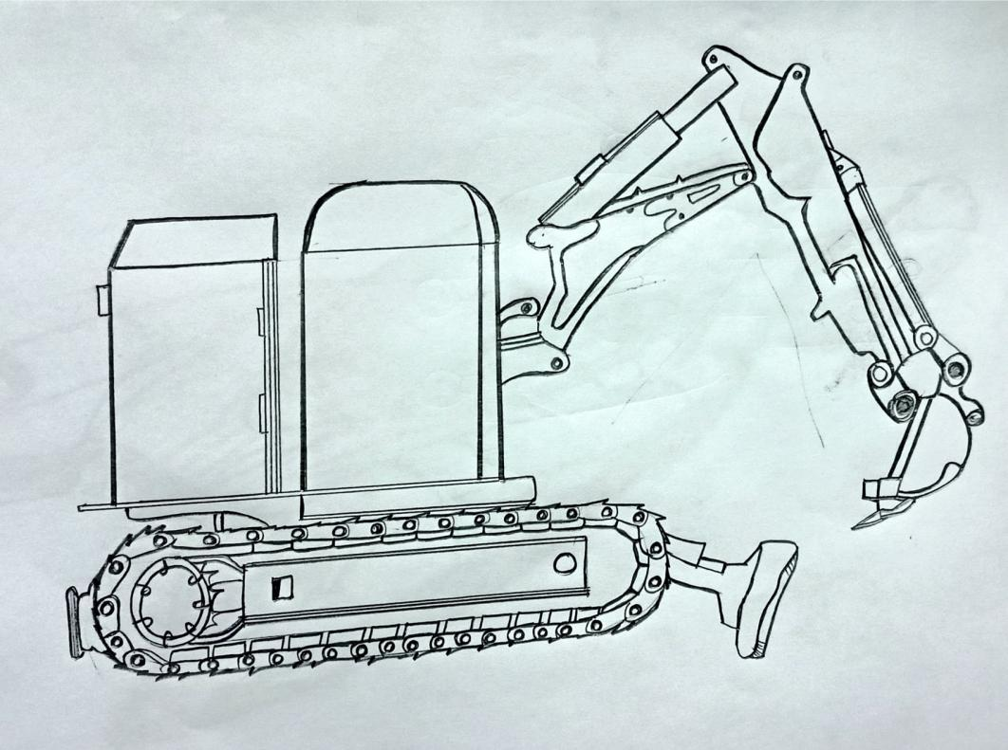

The widen of celestial body is shifting from science fiction to reality astroid mining by private individuals and in space cameras to satellites Aid in the precise locations ofastroids these can't used to extract minerals such as platinum gold,iron or even water.Asteroid mining corporation develops satellites for Asteroid mining.HEO Robotic Utillizes space-based cameras for Asteroid mining.

Space Data:

Leo satellites and multi satellites consultations are increasingly in use for communication.Less provides Bespoke space data.Leo labs offers satellites Tracking and space intelligence

**MEDICAL RESEARCHES**

It includes animal experiments, cell studies,bio chemical ,genetic production of vaccine ,antibiotics public health ,field of research should be done according to the space settlement environment.

And chemical researchers to create new substance according to our livelihood on the settlement.

**MINING**

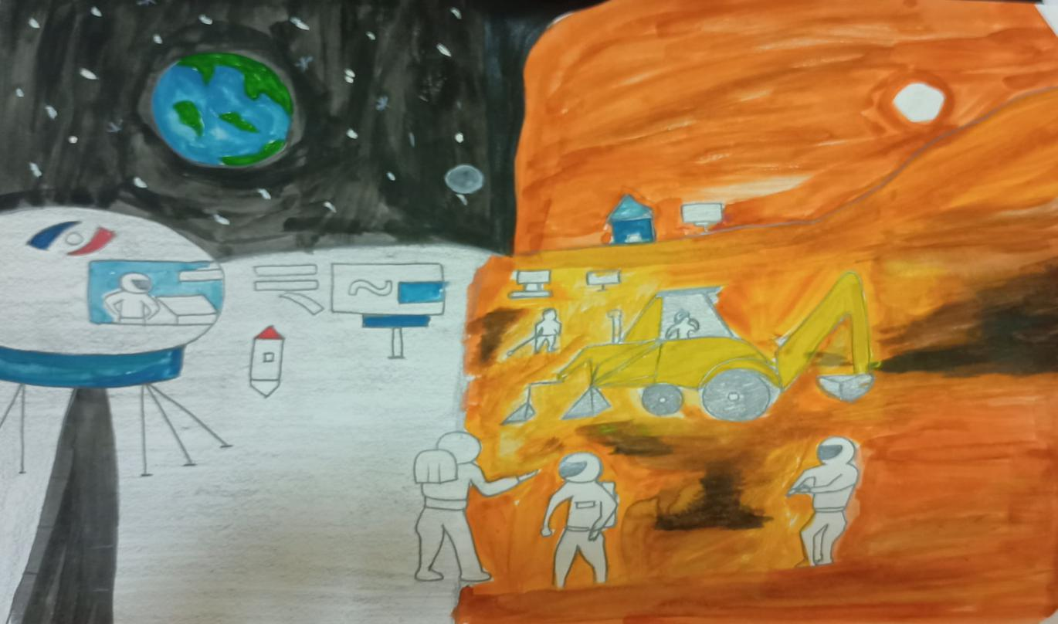

Mining is for the extraction of the resources for our needs on the settlement. Mars contain two moons revolving around that. They are Phobos and Deimos.

Phobos and Deimos are mined for silitates, carbon, carbondioxide and ice

and we extract water from mars from polar ice caps Of it the carbon dioxide, carbon are most necessary requirements for our settlement needs. We create mining robots to the what is an mining also done on the surrounding try with using of robots especially design for asteroid Manning him aluminum titanium on are related a common element available on the math and the total mining crosses he's done by using their about only word operators are available. Mine England there will be a small settlement and required food supply available for the researchers and monitors who monitor the mining process.

TECH INDUSTRY:

Researches on improving communication, transportation, artificial intelligence, mining methods,robotics, interplanetary communication, industries and machinery.

AGRICULTURE INDUSTRY:

Researchers on improving soilless agriculture,plants, agricultural machinery.chemical less agriculture

Researchers on improving technique to capture asteroids expanding our territory planets and space around ATMAN.

CHEMICAL RESEARCHER'S

Pharmaceutical and biochemical researcher's improving production of chemicals in industries.

OTHER RESEARCHERS:

Researcher's on improving education sanitation residences monitoring water saving methods materials

ORE RESOURCES ON MARS:

Mars may contain ores that would be very useful to potential colonies.The abundance of volcanic features together with widespread creating are strong evidence for a variety of ores.While nothing may be found on Mars that would justify the high cost of transport to earth.

The mars ores that future colonist's can obtain from Mars.

The heat production on Mars was more liquid rock called magma.

The key life support compounds O2,N2,H20 are available on Mars soil could be used as radiation shielding &could provide many useful industrial & construction materials.

Components with high chemical energy such as rocket fuels.

IMPORTANT OF STUDY ROCKS ON MARS:

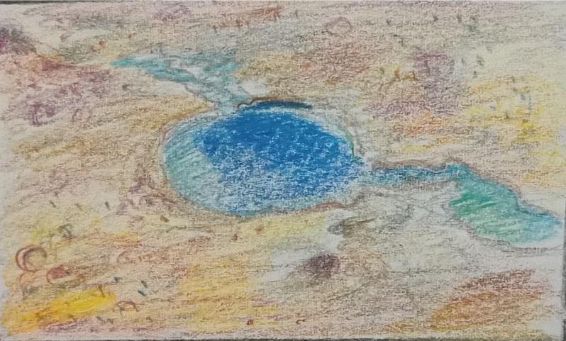

Rocks on Mars tell us the planet's history & it's potential for boring life geologists use the age of rocks to determine the sequence of events in a planets history

AVALIBILITY OF NATURAL RESOURCES ON MARS:

CARBODOXIDE=95.32%

NITROGEN=2.7%

ARGON=1.6%

OXYGEN=0.13%

MONO=0.08%

**CHAPTER-9**

**CONTROLLING POLLUTION**

As we know that damage of the pollution cause many severe issues to the living organisms.

The main pollution for ATMAN

**AIR POLLUTION**

**WATER POLLUTION**

*Smokestacks with electrostatic precipitator (right)

**CONTROLLING AIR POLUTION**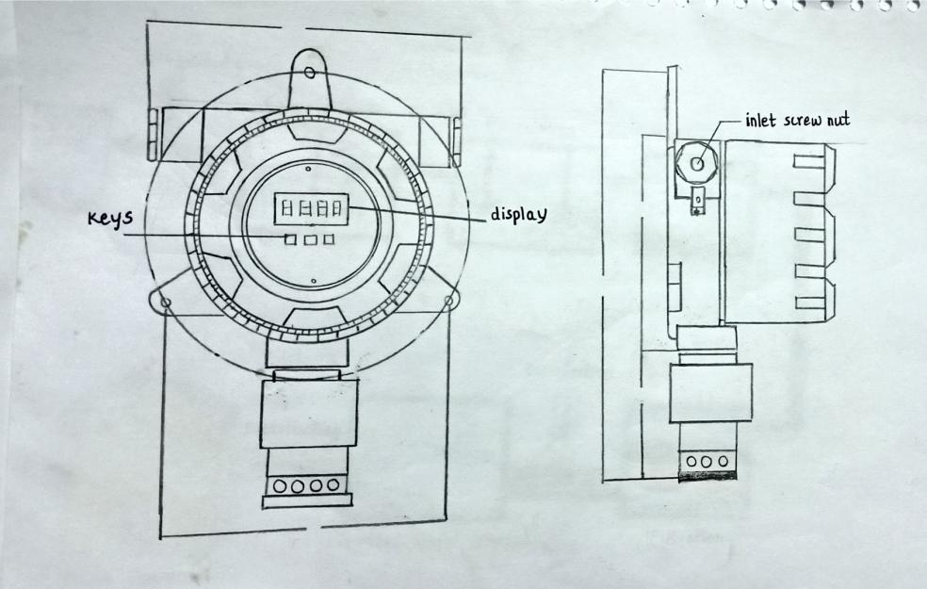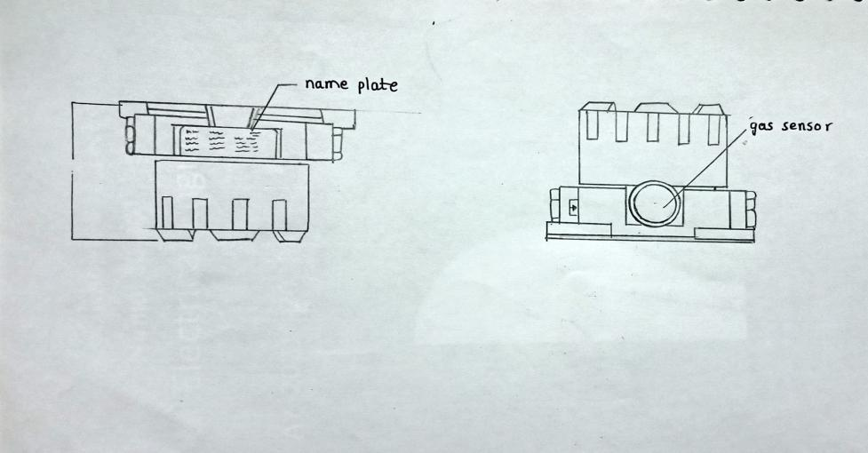

*Smokestacks with scrubbers(right).*particulate materials can also be controlled by proper excavating technique.

**MAJOR CATEGORIES OF WATER POLLUTANTS**

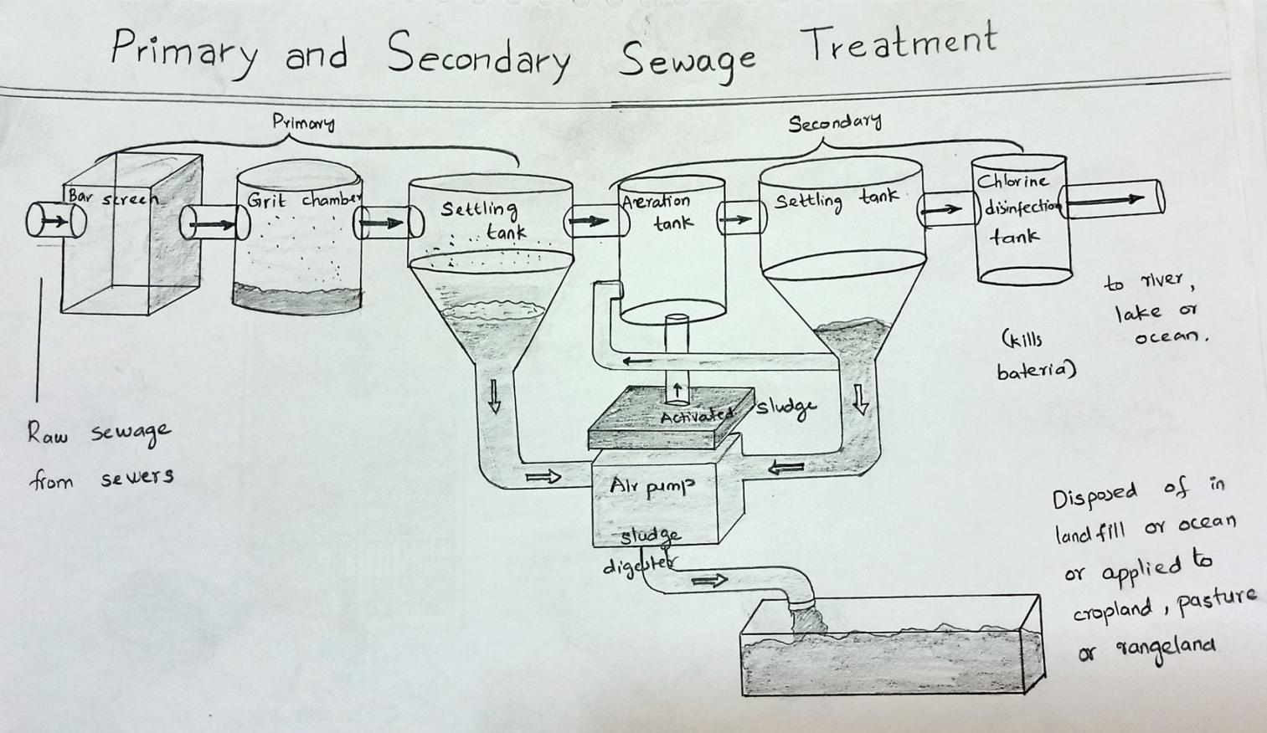

**\*Infectious agents**Bacteria, viruses, protozoa, parasitice worms.

Source,human and animal waste.

**\*Oxygen demanding waste**Organic debris and waste+aerobis bacteria.Source , sewage,freecloits,paper mills, food processing.

**\*In organic chemicals**

Acids,metals,salts.Sources,surfacerunnoff,industrial,efficient,household, cleanses.

\***Radioactive materials**Iodine,radian,uranium,cesium,thorium.Source,coal and nuclear power plants, mining,weapons,production in natural

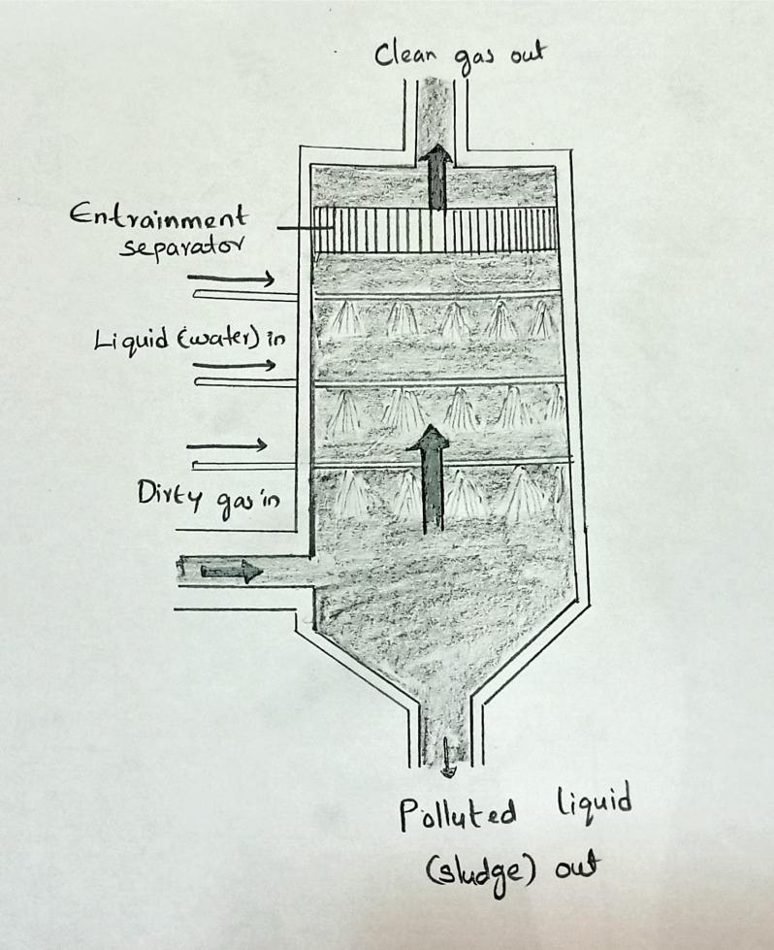

**CHAPTER -10**

**COMMUNICATION**:

In the space settlement ,it is more important to communicate with the people and other sectors.

So,there are ,many types of communication techniques used for internal communication.It is best to use the wireless communication it includes sattellite communication,infrared communication,Broadcast Radio communication,Microwave communication and Mobile communication systems.

**(I) SATTELLITE COMMUNICATION**:

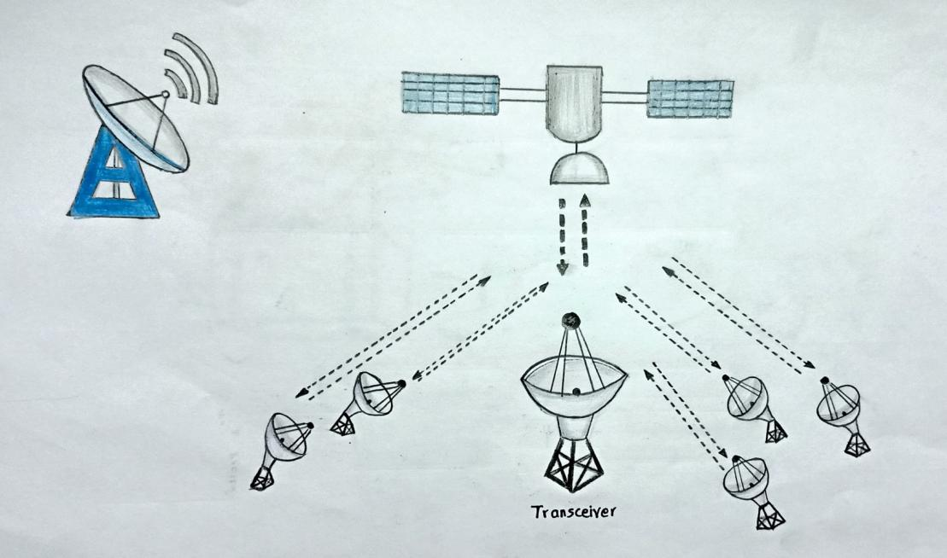

It is the crucial form of wireless communication.

By means of sattellites,people all over the settlement can communicate with each other signals from one torus to another can be sent by using sattellites also.

**(II) INFRARED COMMUNICATION**:

Infrared Communication is present in most homes like in the form of a television remote control.IR transmits information by means of invisible light.This means that on the electromagnetic spectrum it lies between microwaves and visible light.Infrared communication requires a transmitter and a photoreceiver to receive the light beam.Since any disruption to the light will result in the photoreceiver not receiving it.IR will only function when there is a line of sight visibility.That means that if you stand between the transmitter and receiver it will probably not work. NIn our settlement ,this type of communication is used in household activities also we can include in industries like to operate machnies,robots or any other electronic equipment.

**(III)BROADCAST RADIO COMMUNICATION**:

The most famous formof wireless transmission,broadcast radio was probably the first kind of wireless communication.Radio transmitters send our data in the form of radio waves to receiving antennae.Radio waves are forms of electromagnetic signals.Signals are relatively narrow,and waves can be sent across various frequencies.This is why we can able to receive signals from many different radio stations.Applications of Radio communication in our settlement are mobile phones ,wireless computer networks,television broadcasting.And the radio communication is cost effective.

**(IV)MICROWAVE COMMUNICATION**:

Microwave technology is an effective type communication,it is categorized into two types a)Sattellite microwave communication

b)Teriestial microwave communication

**a)Sattellite microwave communication:**s is the most method of transmitting microwave globally .Like infrared technologies,microwave technologies require a clear line of sight.This means that if you want to send a signal over a long distance,sending it upto a sattelliite first is a good idea.This type of communication can be used for many different applications such as communication,broadcasting navigation,weather forecasting etc.Torus communication will be done.

**b)Teriestial microwave communication**:Microwave technologies can be a very secure form of communication.If a signal needs to be transmitted over a short distance,it can be enough to erect two antence with a clear line of sight.The signal can then be transmitted between the two receivers.This negats the need to connect to an outside network.It is used within a local geographical area,like cable connection,telephone relay towers etc.

**(V)MOBILE COMMUNICATION SYSTEM:**

The mobile communication is must in our settlement for the purpose of the communication among the people and for various purposes.This communication is the exchange of voice and data communication without any physical link.Smartphones,Landline telephones are the equipment for this type of communication.

**SMART HOME SECURITY**

Lets start with how IOT helps secure your home. Window and door contacts, glass break and motion detectors, and heat, smoke, and water detectors combined with security alarm pads, cameras, and smart doorbells help secure your home against break-ins, fire, and floods.

**ASTROID MINING**

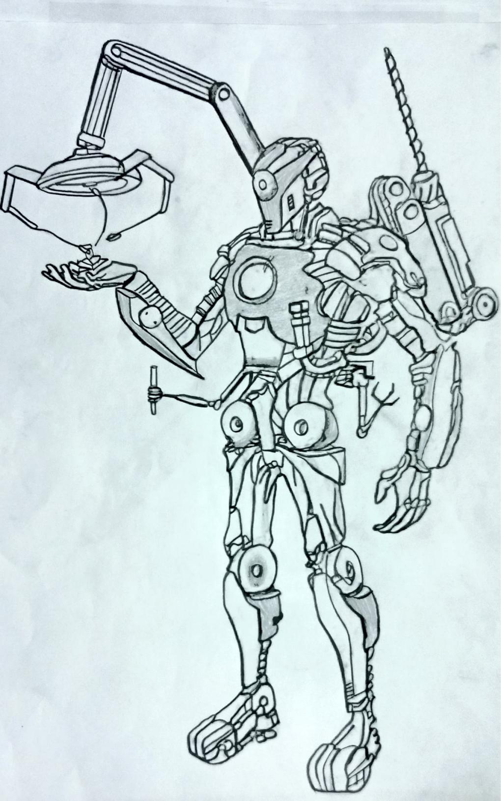

We should select an astroid as target and plans for further steps its behaviour and physical should be known we can mine an astroid in two ways. We can either capture an astroid according to its size or landing on it and doing mining. If the astroid is small (5-10m) we can capture it and if it is a large astroid we land in that and we extract minerals . It has robots to mine the larger astroids.

**INSMALL ASTROIDS**:

Penetrators it catches the astroid and penetrators will penetrate into astroid and extractors will extract the minerals. It has solar penels and signal receiver it also stores the minerals that it extracted from the astroid thrusters are bottom of the astroid minerals.

Spacecrafts will come near to astroid and they will attach the astroid in 3 different sides the attachment takes place in the following way the spacecrafts have strong penetrators penetrated into astroid after penetrating each space crafts starts exerting force in their direction opposite to astroid. The astroid comes to rest the other two spacecrafts leave the astroid the third spacecrafts decreases its speed and starts extracting minerals.

Lunar explorer is a spacecrafts on the mars. It consists of two rooms for astronauts / scientist can the capacity of the lunar explorer is 5 to 6 members. It is used to explorer mars more the scientists will study about the mars deeply lunar explorer contains one research lab. It stays 20 to 25 days on mars after it again move to the settlement. The scientists will collect data and starts research deeply at the research center in the torus.

**ARTICLE 1**

PINTA is an independent, soveregin, secular, social, democratic, state of people which respects human rights, organized with all and for the good of all as a united and democratic republic, for the enjoyment of political freedom, social justice, individualand collective well-being and human solidarity.

**ARTICLE 2**

The official name of the state is republic of ATMAN and the official language is english.

**ARTICLE 3**

In the republic of ATMAN the power is lies in the people, from whom orginates all the power of the state. That power is exercised directiy or through the assemblies, in the of people’s power and other state bodies which derive their authority from these assemblies, in the form and according to the norms established in the constitution and by law.

**ARTICLE 4**

In the republic of ATMAN rules the system of rhe economy based on the people’s ownership of the fundamental means of production and on the abloition of the exploitation of man by man.

**ARTICLE 5**

A) The lands that do not belong to small farmers or to cooperatives formed by them, the plant and animal resources in the republic’s maritime economic area, and means of communications;

B) The factories, chief means of transportation and all those enterprises, banks and facilities, as well as the factories, enterprises and economic facilities and scientific, social, cultural and sports centers built, fostered or purchased by the state and those to be built, fostered or purchased by the state in the future.

**ARTICLE 6**

The state directly administers the goods that make up the property of the entire people’s, or may create and organize enterprises to administer them, whose structure, powers, functions and the system of their relations are prescribed by law.

**ARTICLE 7**

The state controls and directs foreign trade. The law establishes the state institutions and officials authorized to:

- create foreign trade enterprises;

- standardize and regulate export and import transactions; and

- determine the natural persons or legal bodies with judicial powers to carry out these export and import transactions and to signtrade agreements.

**ARTICLE 8**

The state guarantees the right to personal ownership of earnings and savings derived from one’s own work, of the dwelling to which one has legal title and of the other possessions and objects which serve to satisfy one’s material and cultural needs.

**ARTICLE 9**

The state recognizes the right to legal ownership of joint ventures, companies and economic associations which are created as prescribed by law.

**ARTICLE 10**

Anybody who suffers damages unjustly caused by a state official or employee while in the performance of his public functions has the right to claim and obtain the corresponding indemnification as prescribed by law.

**ARTICLE 11**

All children have the same rights, regardless of being born in or out of wedlock.

Any qualification concerning the nature of the filiation is abolished.

**ARTICLE 12**

The parents have the duty to provide nourishment for their children; to help them to defend their legitimate interests and in the realization of their just aspirations; and to contribute actively to their education and integral development as useful and well-prepared citizens for life in a collective society.

It is the children’s duty, in turn, to respect and help their parents.

**ARTICLE 13**

The state orients, foments and promotes education, culture and science in all their manifestations.

Its educational and cultural policy is based on the following principles:

a) the state bases its educational and cultural policy on the progress made in science and technology and universal progressive pedagogical tradition;

b) the state promotes the positivist education of the new generations and the training of children, young people and adults for social life.

**ARTICLE 14**

The state and society give special protection to children and young people.

It is the duty of the family, the schools, the state agencies and the social and mass organizations to pay special attention to the integral development of children and young people.

**ARTICLE 15**

All citizens have equal rights and are subject to equal duties.

**ARTICLE 16**

Discrimination because of race, skin color, sex, national origin, religious beliefs, and any other form of discrimination harmful to human dignity is strictly forbidden and will be severely punished by law.

**ARTICLE 17**

Women and men have the same rights in the economic, political, cultural and social fields, as well as in the family.

The state guarantees women the same opportunities and possibilities as men, in order to achieve women’s full participation in the development of the country.

**ARTICLE 18**

All those who work have the right to rest, which is guaranteed by the eight-hour workday, a weekly rest period and annual paid vacations.

**ARTICLE 19**

By means of the Social Security System the state assures adequate protection to every citizen who is unable to work because of age, illness or disability.

If the citizen dies, this protection will be extended to his family.

**ARTICLE 20**

Everyone has the right to physical education, sports and recreation.

Enjoyment of this right is assured by including the teaching and practice of physical education and sports in the curricula of the national educational system; and by the broad nature of the instruction and means placed at the service of the people, which makes possible the practice of sports and recreation on a mass basis.

**ARTICLE 21**

The home is inviolable. Nobody can enter the home of another against his will, except in those cases foreseen by law. Any form of violation of the inviolability of the home except those cases foreseen by law will be severely punished by law.

**ARTICLE 22**

Freedom and inviolability of persons is assured to all those who live in the country.

Nobody can be arrested, except in the manner, with the guarantees and in the cases indicated by law.

**ARTICLE 23**

Confiscation of property is only applied as a punishment by the authorities in the cases and by the methods determined by law.

**ARTICLE 24**

Penal laws are retroactive when they benefit the accused or person who has been sentenced. Other laws are not retroactive unless the contrary is decided for reasons of social interest or because it is useful for public purposes.

**ARTICLE 25**

Strict fulfillment of the Constitution and the laws is an inexcusable duty of all. The constitution is above all laws, and all laws must be written taking the constitution into consideration.

**ARTICLE 26**

The National Assembly is the only body in the Republic invested with constituent and legislative authority.

**ARTICLE 27**

The National Assembly, on meeting for a new legislature, elects from among its deputies its president, vice president and secretary. The law regulates the manner and procedure in which the Assembly is constituted and carries out this election.

**ARTICLE 28**

It is the duty of the deputies to the National Assembly of People'’ Power to exercises their duties in benefit of the people'’ interests, stay in contact with their electors, listen to their problems, suggestions and criticism, and explain the policy of the state. They will also render account to them of the results of their activities, as prescribed by law.

**ARTICLE 29** The proposal of laws is the responsibility of:

a) the deputies to the National of People’s Power;

b) the Council of State;

c) the commissions of The National Assembly;

f) the Office of the Attorney General of the Republic, in matters within its jurisdiction;

**ARTICLE 30**

In cases of the absence, illness or death of the president of the Council of State, the first vice president assumes the president’s duties.

LOCAL BODIES OF PEOPLE’S POWER:

**ARTICLE 31**

For the exercise of their functions the local Assemblies of People’s Power find support in the People’s Councils and the initiative and broad participation of the population and they act in close coordination with the social and mass organizations.

**ARTICLE 32**

The Municipal Assemblies of People’s Power are renovated every two and a half years, which is the delegates’ term of office.

**ARTICLE 33**

The administration bodies which constitute the Provincial and Municipal Assemblies of People’s Power work on a collegiate basis and their composition, integration, functions and duties are established by law.

**ARTICLE 34**

For administering justice all courts function in a collegiate form and professional and lay judges participate in them with equal rights and duties.

**ARTICLE 35**

This Constitution can only be totally or partially modified by The National Assembly, except for the first five articles, by means of resolutions adopted by roll-call vote by a majority of no less than two-thirds of the total number of members.

.

K’’